

**Department of Electrical and Computer Engineering**

**ENCS3320 - Computer Networks**

**Summer Semester 2023/2024**

**Project#2: Network Design**

**Prepared by:**

Mouath Masalmah - 1220179

Zaid Mousa - 1221833

Bahaa Bani Shamsaa - 1220252

**Instructor:** Dr.Ibrahim Nemers

**Section:** SECTION_1

Table of Contents

Table of figure: 3

Task 0: 6

Part1: 7

1.How we define IP 7

2.IPv4 7

3.The Network Part 7

4.The Host Part 7

Part2: 8

Part3: 10

Task 1: 21

Part1: 21

Part2: 33

Part3: 38

Task 2: 39

part 1: 39

part 2: 41

Part 3: 43

Task 3: 44

Task 4: 49

part 1: 49

part 2: 60

Pie Chart: 72

Work and report: 72

The References: 73

# Table of figure:

Figure 1: IPs in topology 9

Figure 2: labtop0 IP Configuration 10

Figure 3: PC0 IP Configuration 11

Figure 4: router0 - FastEthernet0/0 11

Figure 5: Labtop3 IP Configuration 12

Figure 6: PC1 IP Configuration 12

Figure 7: PC2 IP Configuration 13

Figure 8: PC3 IP Configuration 13

Figure 9: Router1 - FastEthernet0/0 14

Figure 10: Router1 - FastEthernet1/0 14

Figure 11: Labtop2 IP Configuration 15

Figure 12: PC4 IP Configuration 15

Figure 13: Router2 - FastEthernet0/0 16

Figure 14: DNS server IP Configuration 16

Figure 15: HTTP server IP Configuration 17

Figure 16: labtop1 IP Configuration 17

Figure 17: labtop4 IP Configuration 18

Figure 18: PC5 IP Configuration 18

Figure 19: PC6 IP Configuration 19

Figure 20: Router3 - FastEthernet0/0 19

Figure 21: Router3 - FastEthernet1/0 20

Figure 22: open end device tap 21

Figure 23: select and insert end device 22

Figure 24: Labtop0 IP Configuration 22

Figure 25: PC0 IP Configuration 23

Figure 26: Router0 - FastEthernet0/0 23

Figure 27: Labtop3 IP Configuration 24

Figure 28: PC1 IP Configuration 24

Figure 29: PC2 IP Configuration 25

Figure 30: PC3 IP Configuration 25

Figure 31: Router1 - FastEthernet0/0 26

Figure 32: Router1 - FastEthernet1/0 26

Figure 33: Labtop2 IP Configuration 27

Figure 34: PC4 IP Configuration 27

Figure 35: Router - FastEthernet0/0 28

Figure 36: DNS server IP Configuration 28

Figure 37: HTTP server IP Configuration 29

Figure 38: Labtop1 IP Configuration 29

Figure 39: Labtop4 IP Configuration 30

Figure 40: PC5 IP Configuration 30

Figure 41: PC6 IP Configuration 31

Figure 42: Router3 - FastEthernet0/0 31

Figure 43: Router3 - FastEthernet1/0 32

Figure 44: open router tap 33

Figure 45: select and insert router 34

Figure 46: open switch tap 34

Figure 47: select and insert switch 35

Figure 48: Router0 - IOS Command 35

Figure 49: Router1 - IOS Command 36

Figure 50: Router2 - IOS Command 36

Figure 51: Router3 - IOS Command 37

Figure 52: IPs in topology 38

Figure 53: HTTP server – File Manager 39

Figure 54: HTTP server IP Configuration 40

Figure 55: DNS server - File Manager 41

Figure 56: DNS server IP Configuration 42

Figure 57: PC5 Web Brawser 43

Figure 58: PC5 Web Brawser 43

Figure 59: Router1 ospf 44

Figure 60: Router2 ospf 45

Figure 61: Router3 ospf 46

Figure 62: Router0 ospf 47

Figure 63: PC0 tracert and ping 49

Figure 64: Labtop0 tracert and ping 50

Figure 65: Labtop4 tracert and ping 51

Figure 66: PC6 tracert and ping 52

Figure 67: Labtop1 tracert and ping 53

Figure 68: PC5 tracert and ping 54

Figure 69: Labtop2 tracert and ping 55

Figure 70: Labtop3 tracert and ping 56

Figure 71: Labtop3 tracert and ping 57

Figure 72: PC2 tracert and ping 58

Figure 73: PC1 tracert and ping 59

Figure 74: PC0 Web Page 60

Figure 75: PC0 Web Page 60

Figure 76: Labtop0 Web Page 61

Figure 77: Labtop0 Web Page 61

Figure 78: Labtop4 Web Page 62

Figure 79: Labtop4 Web Page 62

Figure 80: PC6 Web Page 63

Figure 81: PC6 Web Page 63

Figure 82: Labtop1 Web Page 64

Figure 83: Labtop1 Web Page 64

Figure 84: PC5 Web Page 65

Figure 85: PC5 Web Page 65

Figure 86: PC4 Web Page 66

Figure 87: PC4 Web Page 66

Figure 88: Labtop2 Web Page 67

Figure 89: Labtop2 Web Page 67

Figure 90: Labtop3 Web Page 68

Figure 91: PC2 Web Page 69

Figure 92: PC3 Web Page 70

Figure 93: PC1 Web Page 71

Figure 94: pie chart 72

# Task 0:

|  |  |  |  |  |  |  |
| --- | --- | --- | --- | --- | --- | --- |
| **Subnet** | **Subnet Mask “/x”** | **Network IP** | **Broadcast IP** | **First IP** | **Last IP** | **#hosts** |
| **NET 1** | 255.255.255.224/27 | 179.01.8.64 | 179.01.8.95 | 179.01.8.65 | 179.01.8.94 | 30 |
| **NET 2** | 255.255.255.196/26 | 179.01.8.0 | 179.01.8.63 | 179.01.8.1 | 179.01.8.92 | 60 |
| **NET 3** | 255.255.255.224/27 | 179.01.8.96 | 179.01.8.127 | 179.01.8.97 | 179.01.8.126 | 30 |
| **NET 4** | 255.255.255.240/28 | 179.01.8.128 | 179.01.8.143 | 179.01.8.129 | 179.01.8.142 | 14 |
| **R0-R1 LINK** | 255.255.255.252/30 | 179.01.8.144 | 179.01.8.145 | 179.01.8.146 | 179.01.8.147 | 2 |
| **R0-R3 LINK** | 255.255.255.252/30 | 179.01.8.156 | 179.01.8.157 | 179.01.8.158 | 179.01.8.159 | 2 |
| **R1-R2 LINK** | 255.255.255.252/30 | 179.01.8.148 | 179.01.8.149 | 179.01.8.150 | 179.01.8.151 | 2 |
| **R2-R3 LINK** | 255.255.255.252/30 | 179.01.8.152 | 179.01.8.153 | 179.01.8.154 | 179.01.8.155 | 2 |

## Part1:

### 1.How we define IP

* We used the IP of one of the members, which is IP 1220179, where we took the last 2 bits and put them first (ex: 179.01.8.64) and took the 2 before the last and put them in the second (ex: 179.01.8.64).

### 2.IPv4

* Internet Protocol version 4 ( IPv4 ): is a core system that enables communication between devices on the Internet. It uses 32-bit addresses, allowing for about 4.3 billion unique combinations. These addresses are typically written as four numbers separated by dots, like `179.01.x.x`, where each number can range from 0 to 255.

### 3.The Network Part

* The **Network Part** of an IP address identifies which network a device is on. Routers use this part to send data to the correct network. For example, in `179.01.8.1` with the subnet mask `255.255.255.0`, the first two numbers `179.01` are the network part.

### 4.The Host Part

* The **Host Part** pinpoints the specific device within that network. It’s unique to each device on the same network. In the same example, `8.1` is the host part, identifying the particular device.

## Part2:

1. **Identify the Required Subnets:**

- Start by identifying the number of subnets required and the number of hosts needed in each subnet. In this case, we have four main subnets (NET 1, NET 2, NET 3, NET 4) and four point-to-point links (R0-R1 LINK, R0-R3 LINK, R1-R2 LINK, R2-R3 LINK).

2. **Determine the Subnet Mask:**

- Based on the number of hosts required, select the appropriate subnet mask.

- For example:

- **NET 1:** Requires 30 hosts, so a /27 subnet mask (255.255.255.224) is suitable.

- **NET 2:** Requires 60 hosts, so a /26 subnet mask (255.255.255.192) is suitable.

- **Point-to-Point Links:** Require 2 hosts each, so a /30 subnet mask (255.255.255.252) is appropriate.

3. **Calculate Network, Broadcast, and Usable IP Addresses:**

- Using the subnet mask, calculate the network address, broadcast address, and the range of usable IP addresses for each subnet.

- For example, for **NET 1**:

- Network IP: 179.01.8.64

- Broadcast IP: 179.01.8.95

- Usable IPs: 179.01.8.65 to 179.01.8.94

4. **Fill in the Table:**

- For each subnet, fill in the table with the calculated values. Ensure the broadcast IP is correct, and the first and last usable IPs are within the correct range.

5. **Verify IP Allocation:**

- Double-check that no IP addresses overlap between subnets and that all IPs are accounted for.

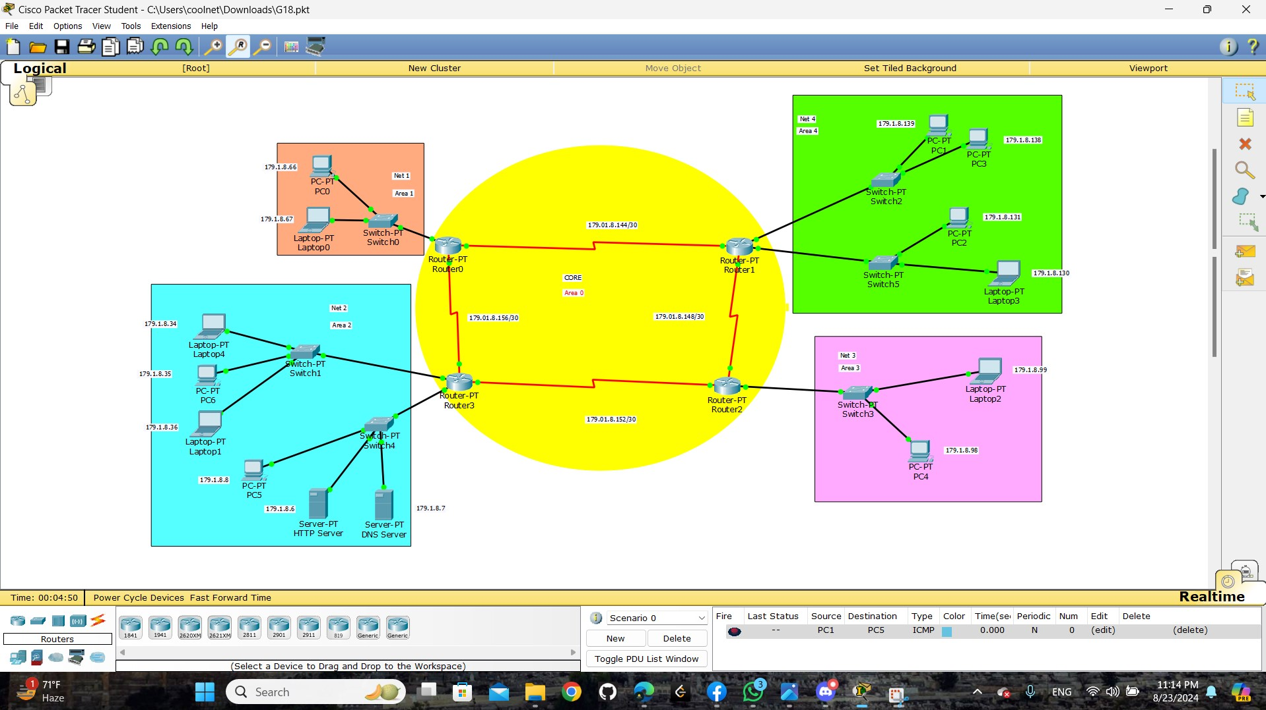

Figure : IPs in topology

## Part3:

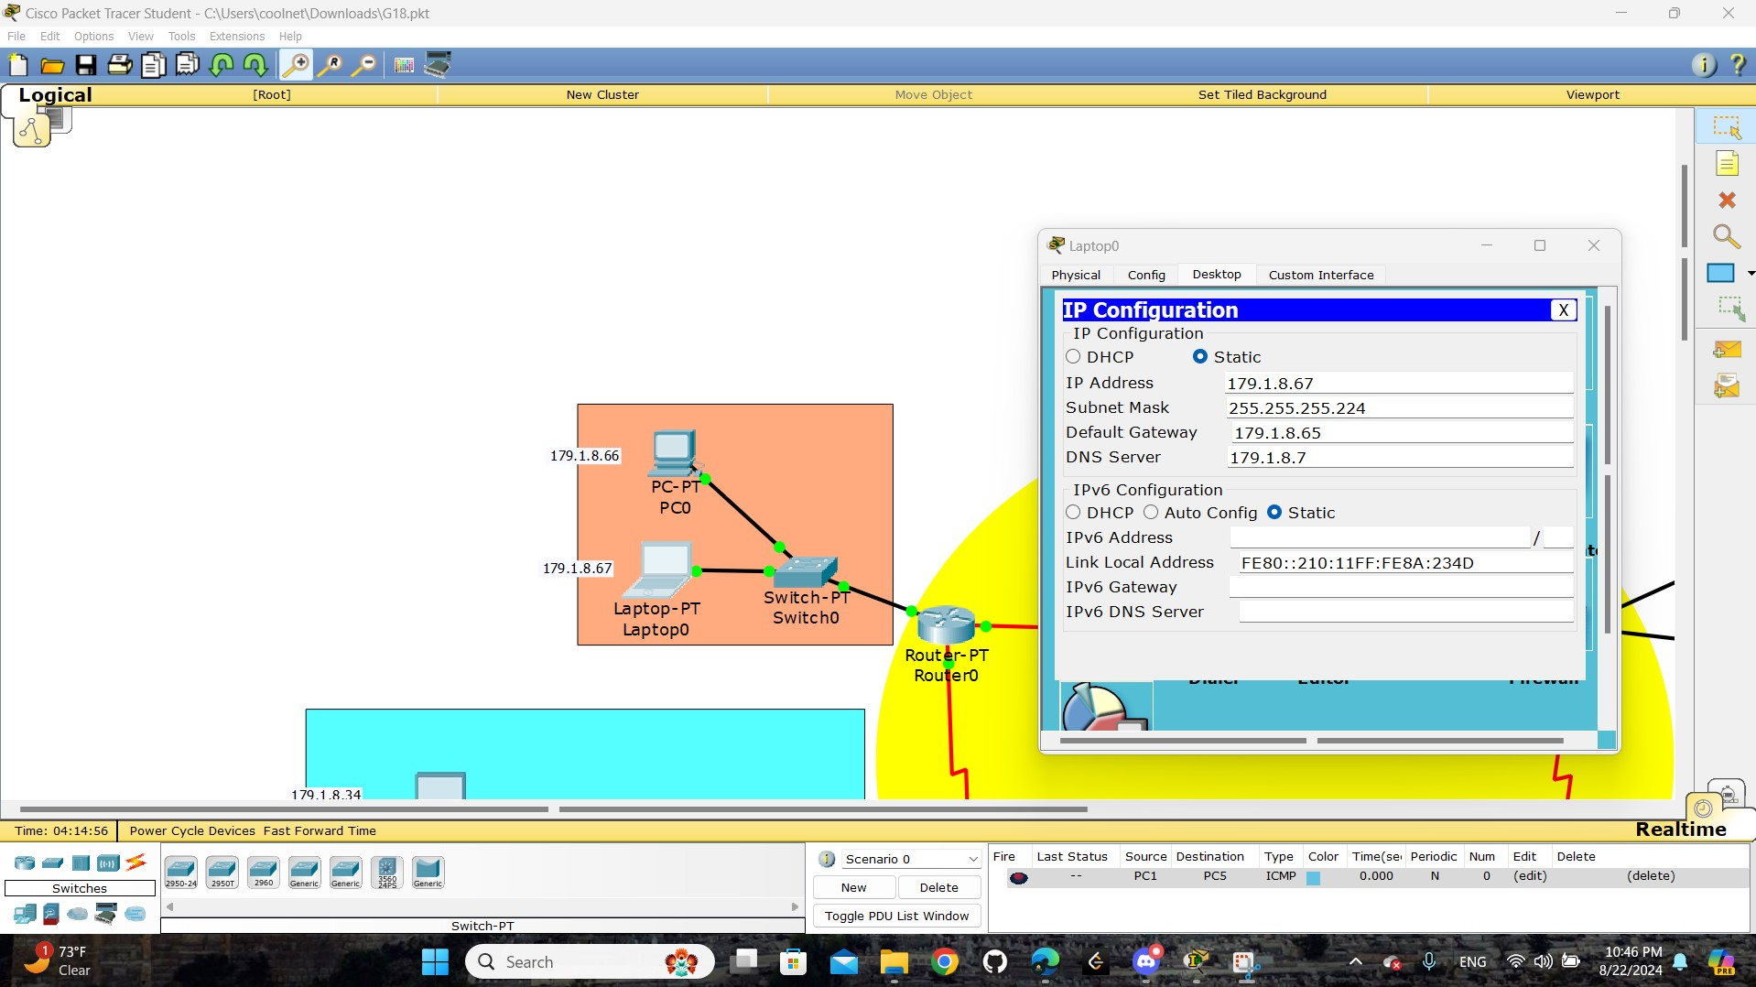

Figure : labtop0 IP Configuration

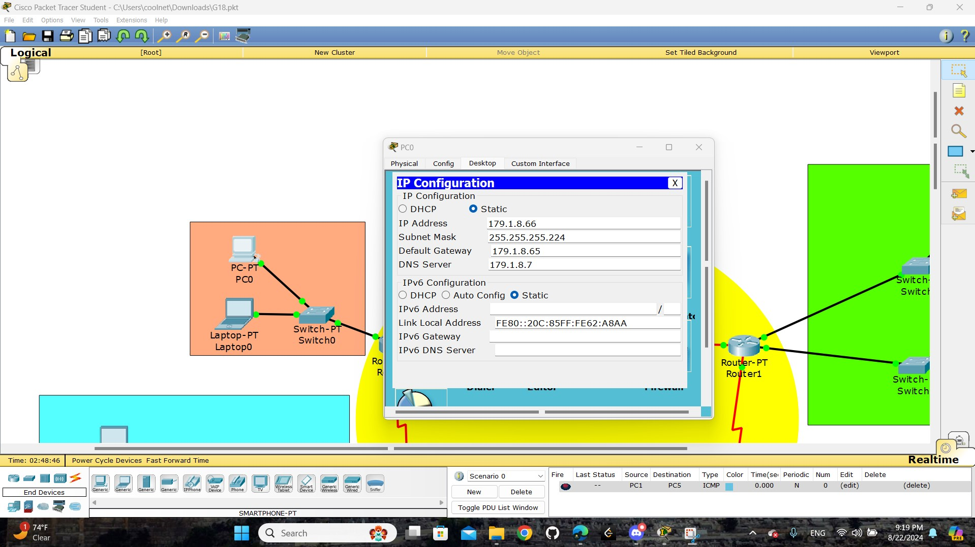

Figure : PC0 IP Configuration

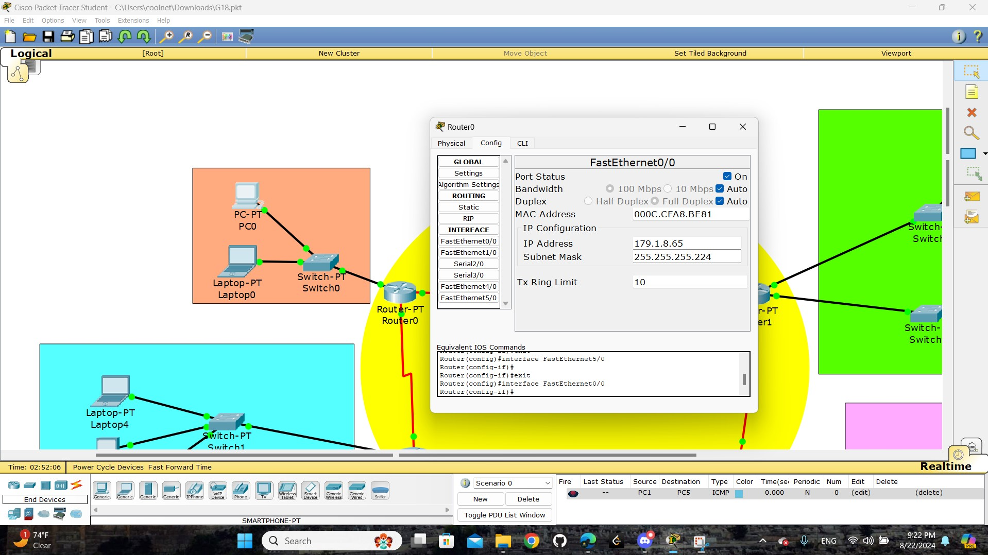

Figure : router0 - FastEthernet0/0

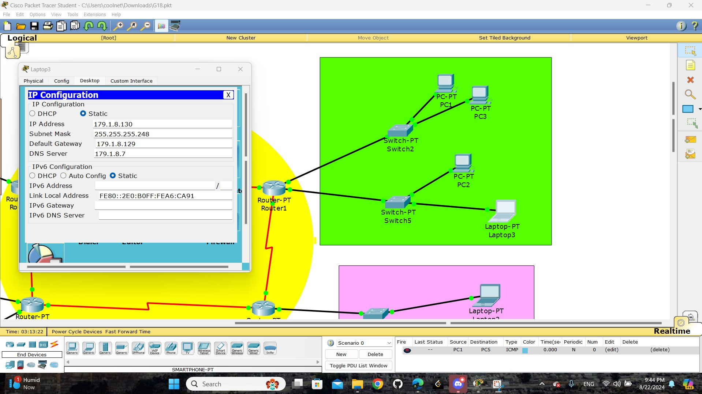

Figure : Labtop3 IP Configuration

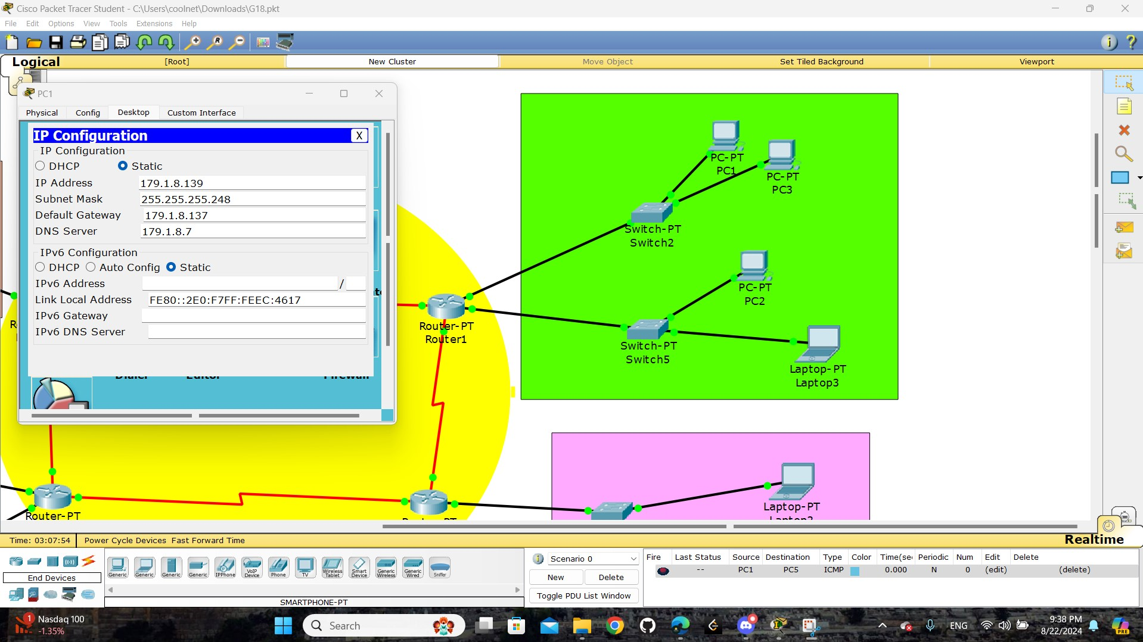

Figure : PC1 IP Configuration

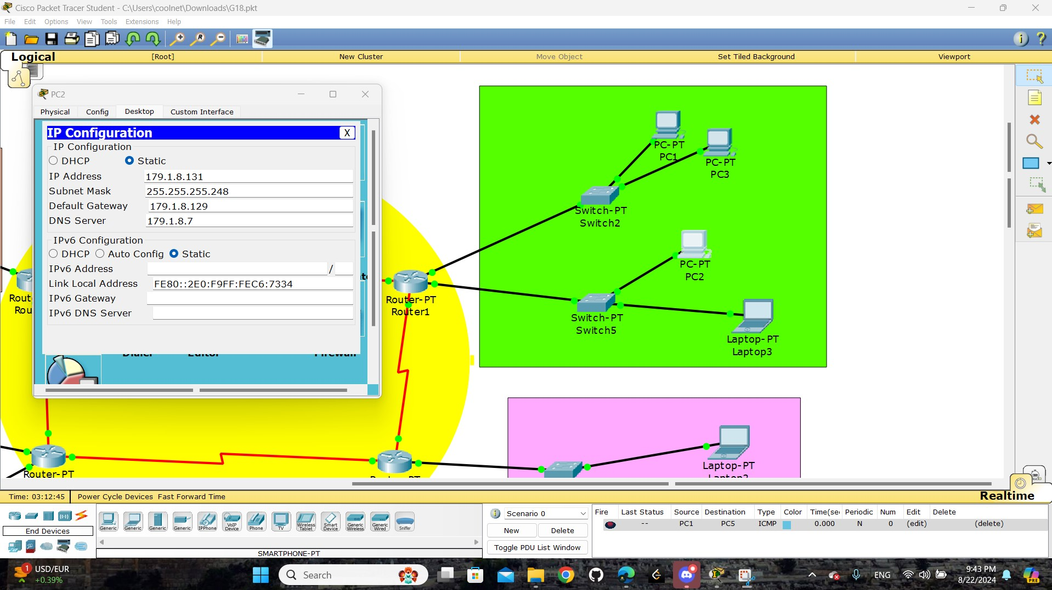

Figure : PC2 IP Configuration

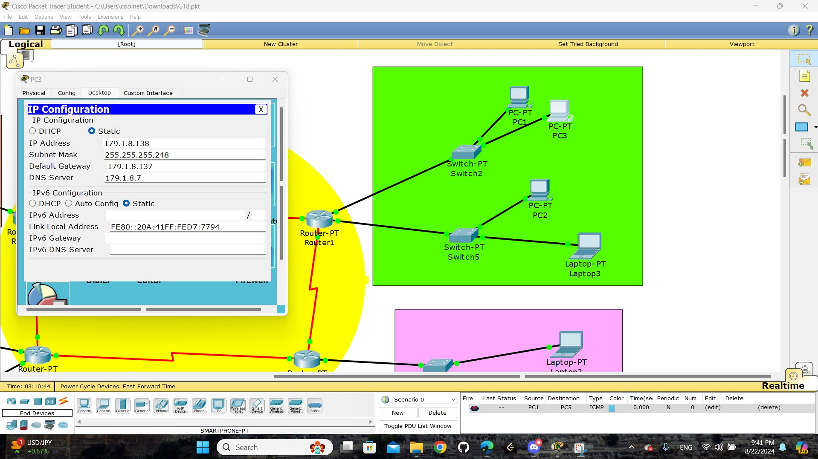

Figure : PC3 IP Configuration

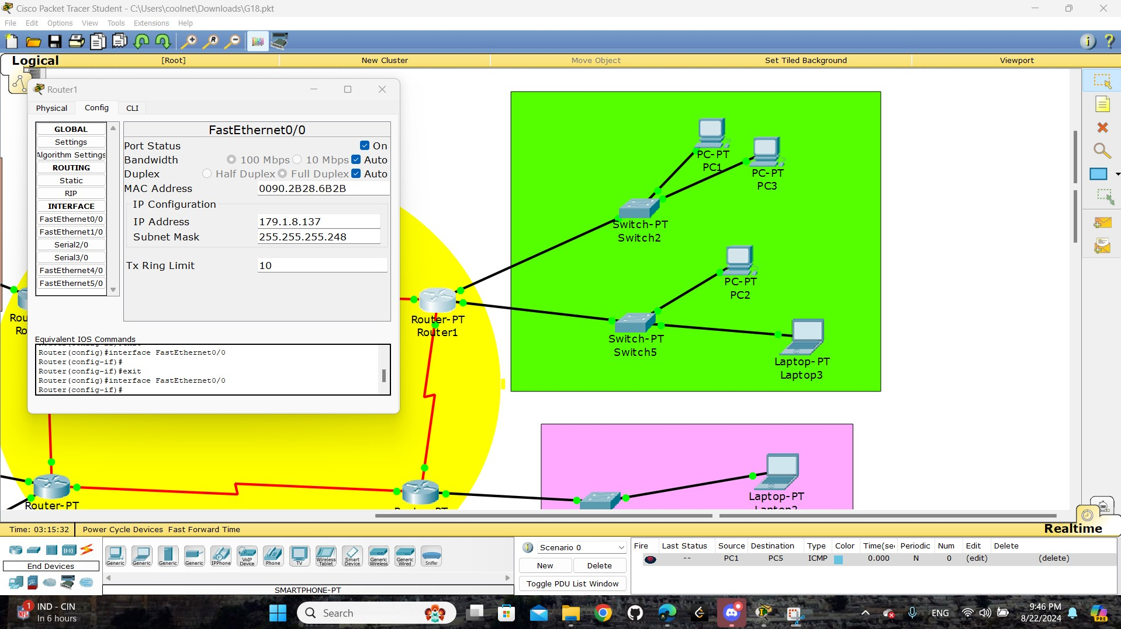

Figure : Router1 - FastEthernet0/0

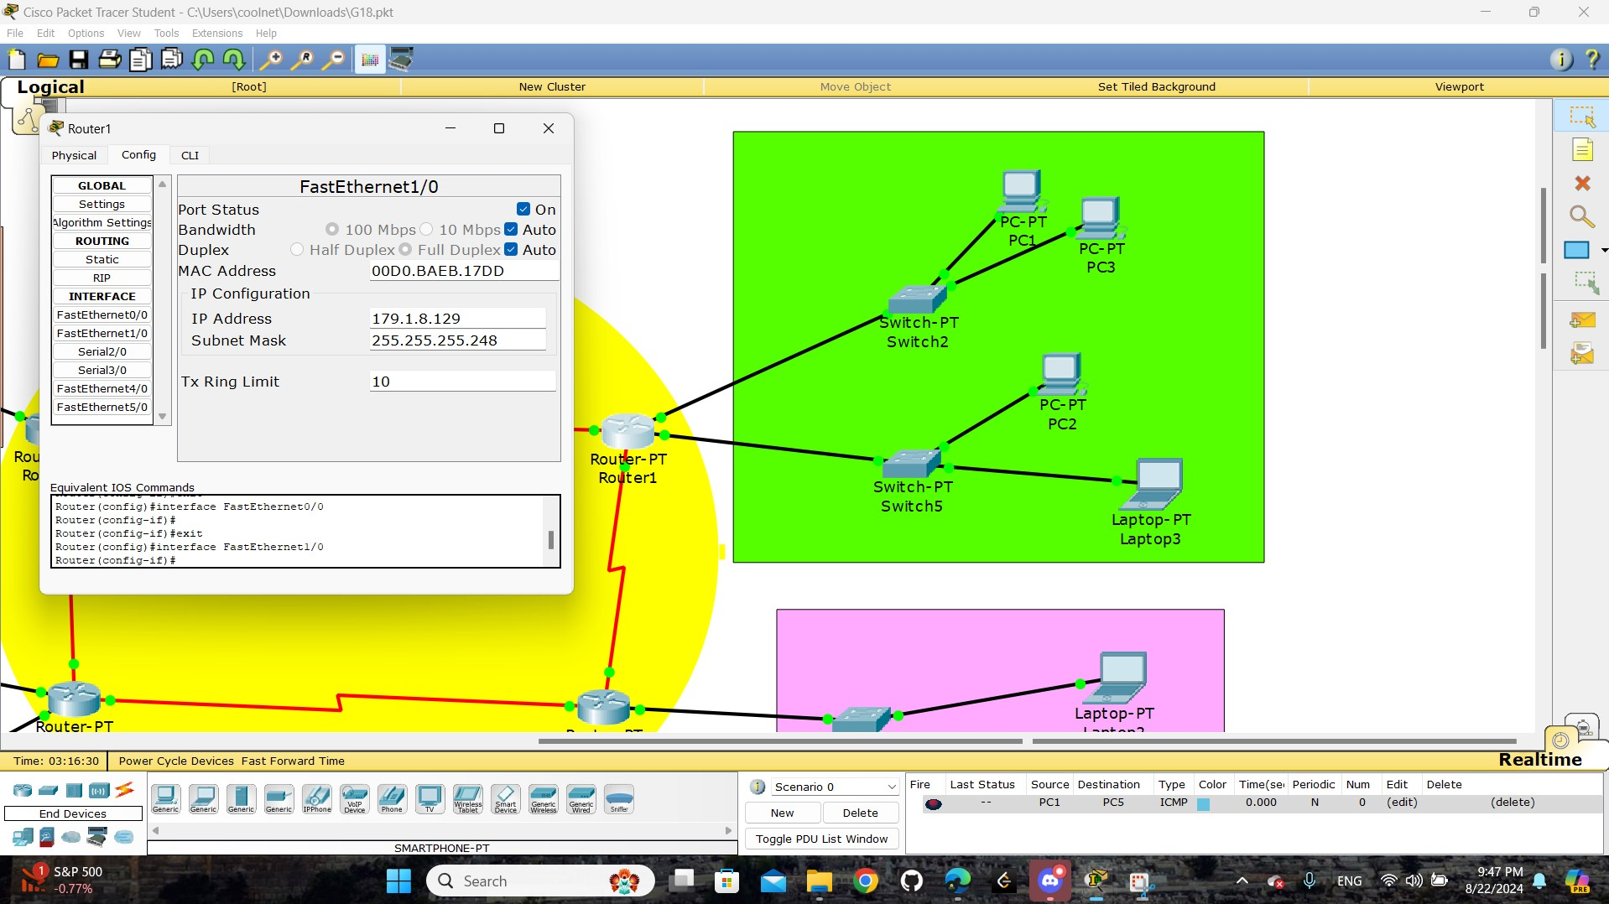

Figure : Router1 - FastEthernet1/0

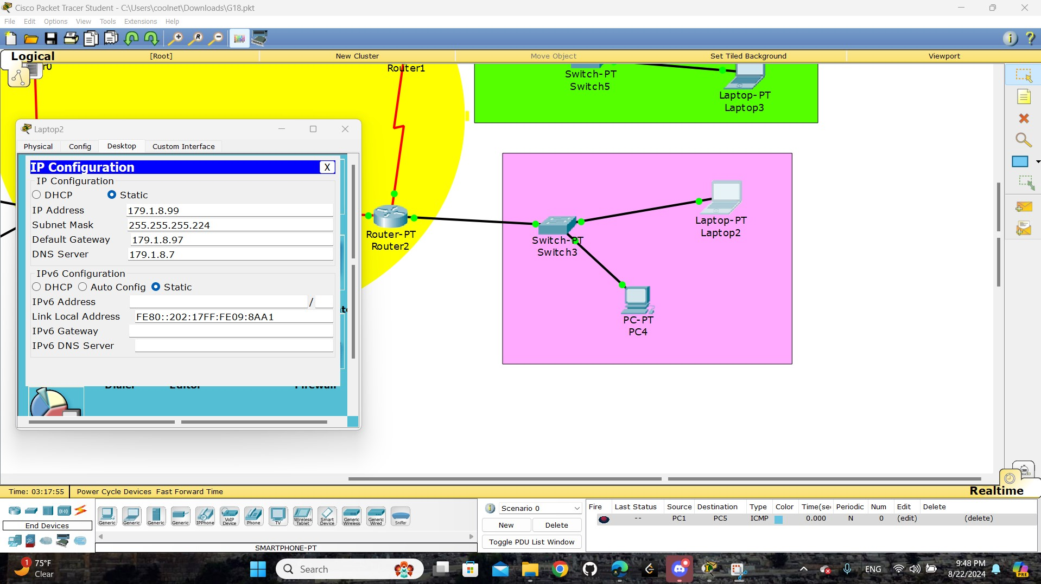

Figure : Labtop2 IP Configuration

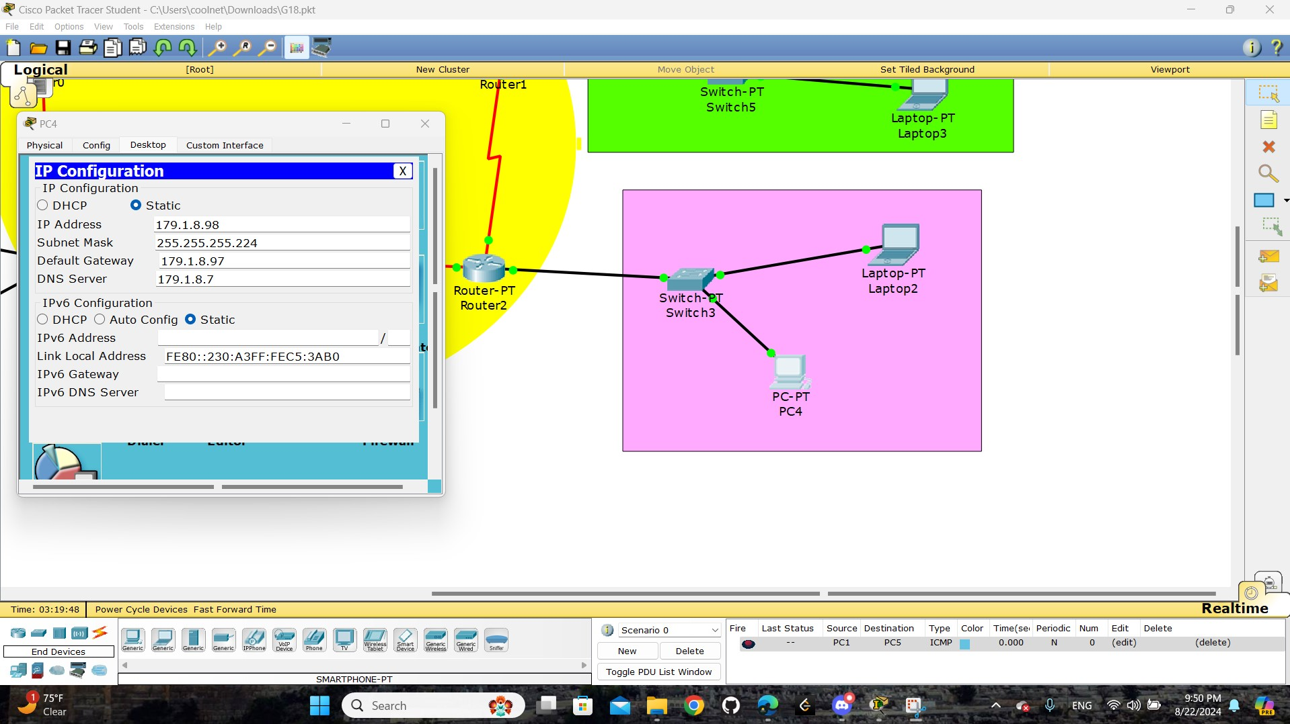

Figure : PC4 IP Configuration

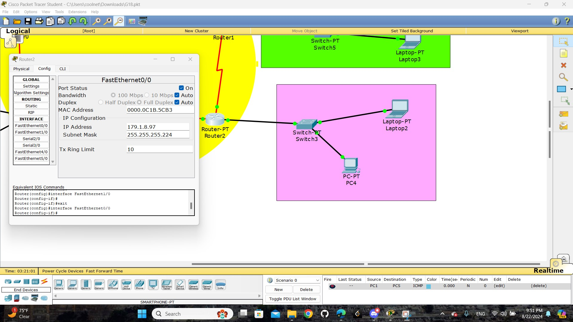

Figure : Router2 - FastEthernet0/0

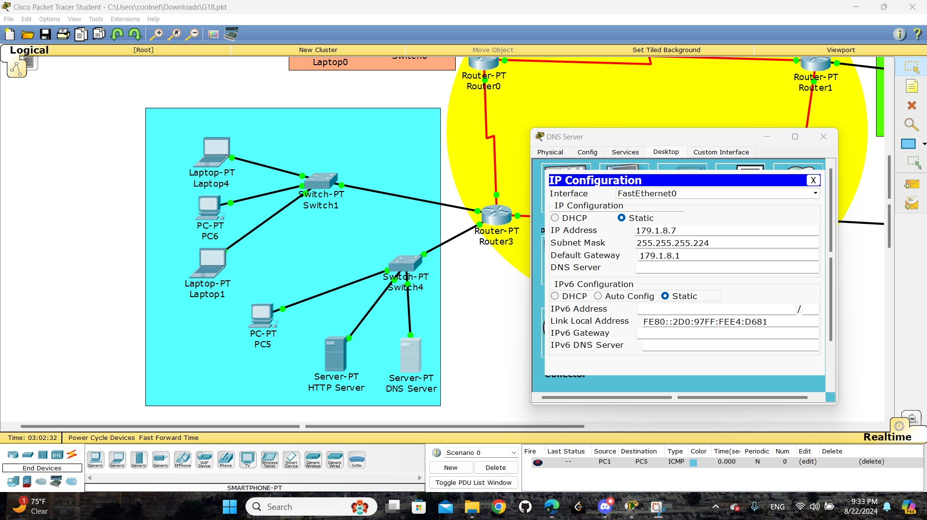

Figure : DNS server IP Configuration

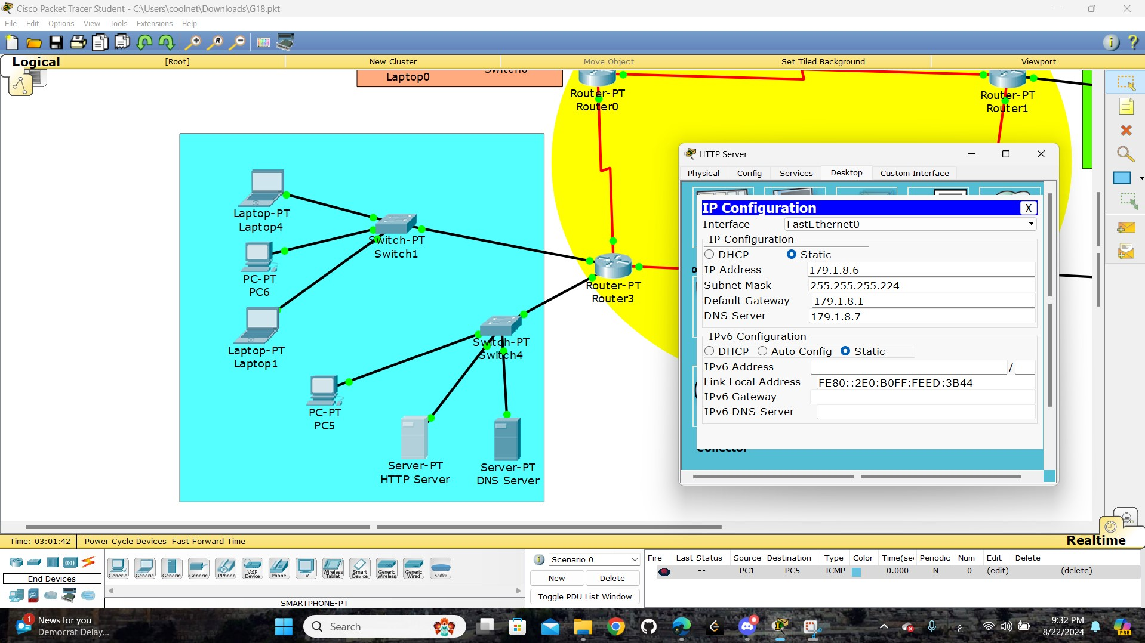

Figure : HTTP server IP Configuration

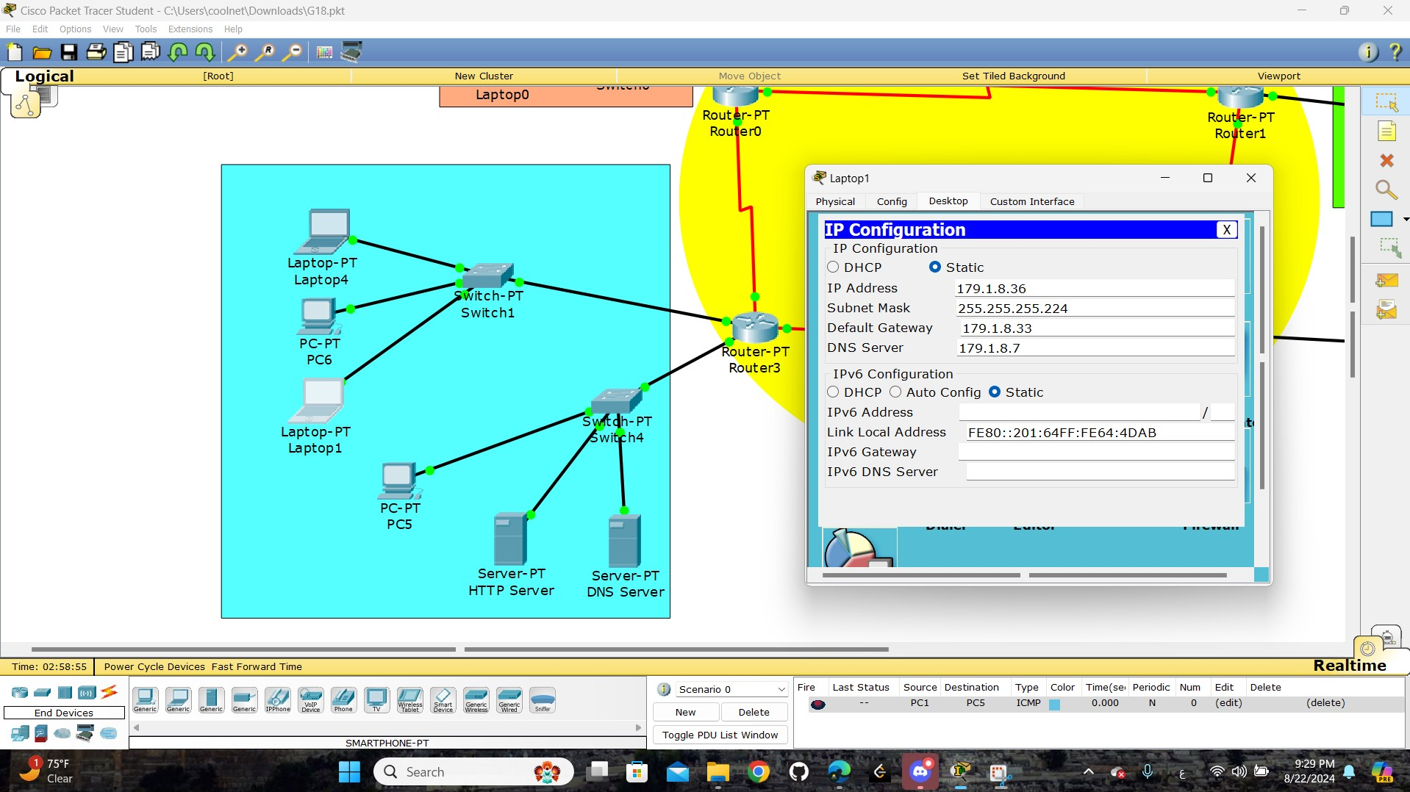

Figure : labtop1 IP Configuration

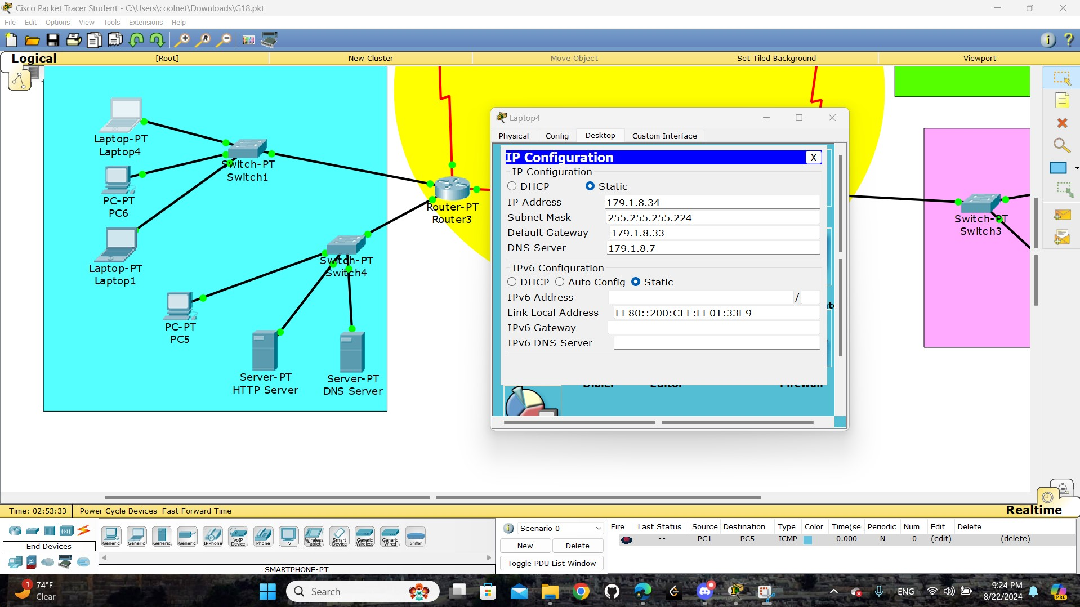

Figure : labtop4 IP Configuration

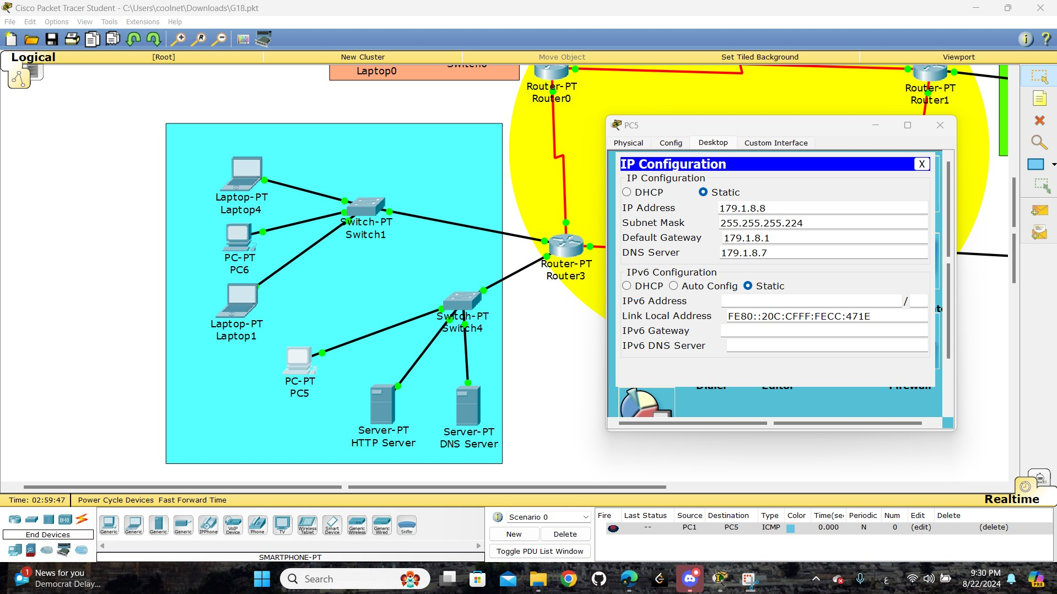

Figure : PC5 IP Configuration

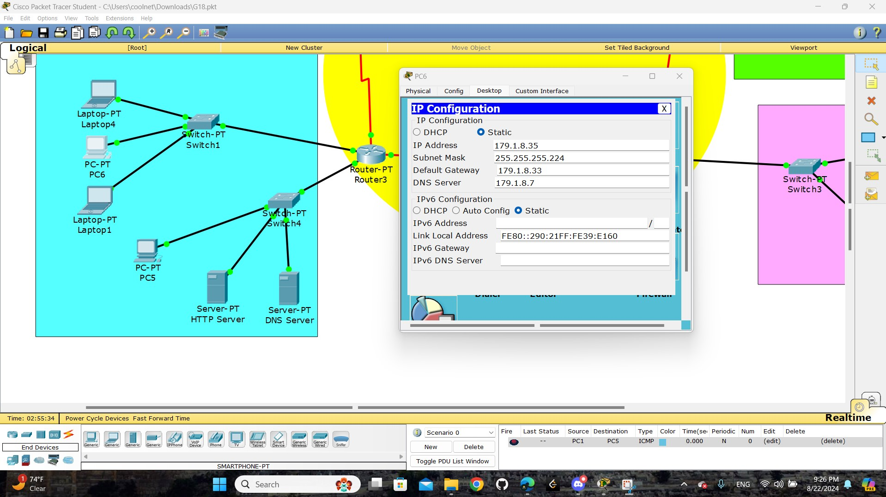

Figure : PC6 IP Configuration

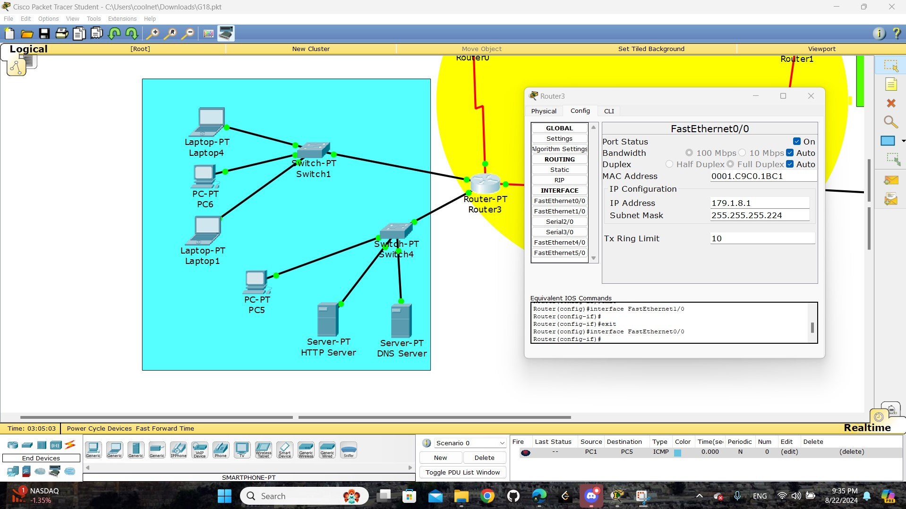

Figure : Router3 - FastEthernet0/0

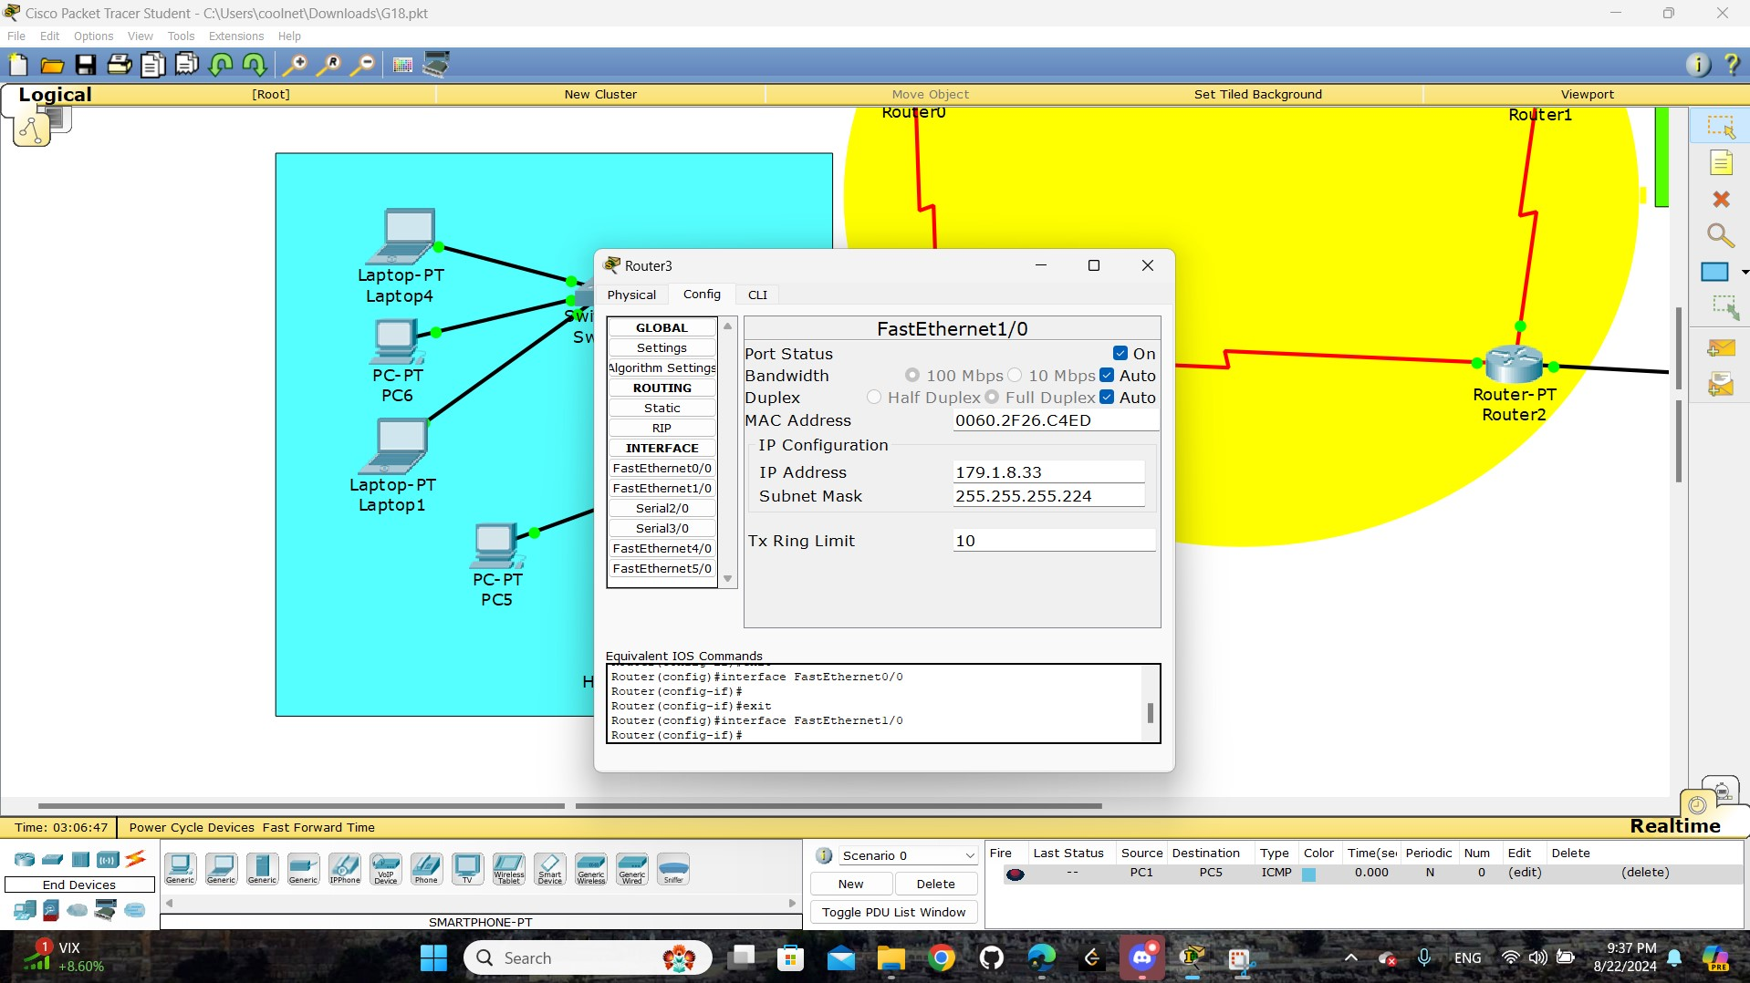

Figure : Router3 - FastEthernet1/0

These images are to display the details of each device on the network and these details are

“ IP Configuration, IP Address, Subnet Mask, Default Gateway, DNS Server “.

# Task 1:

## Part1:

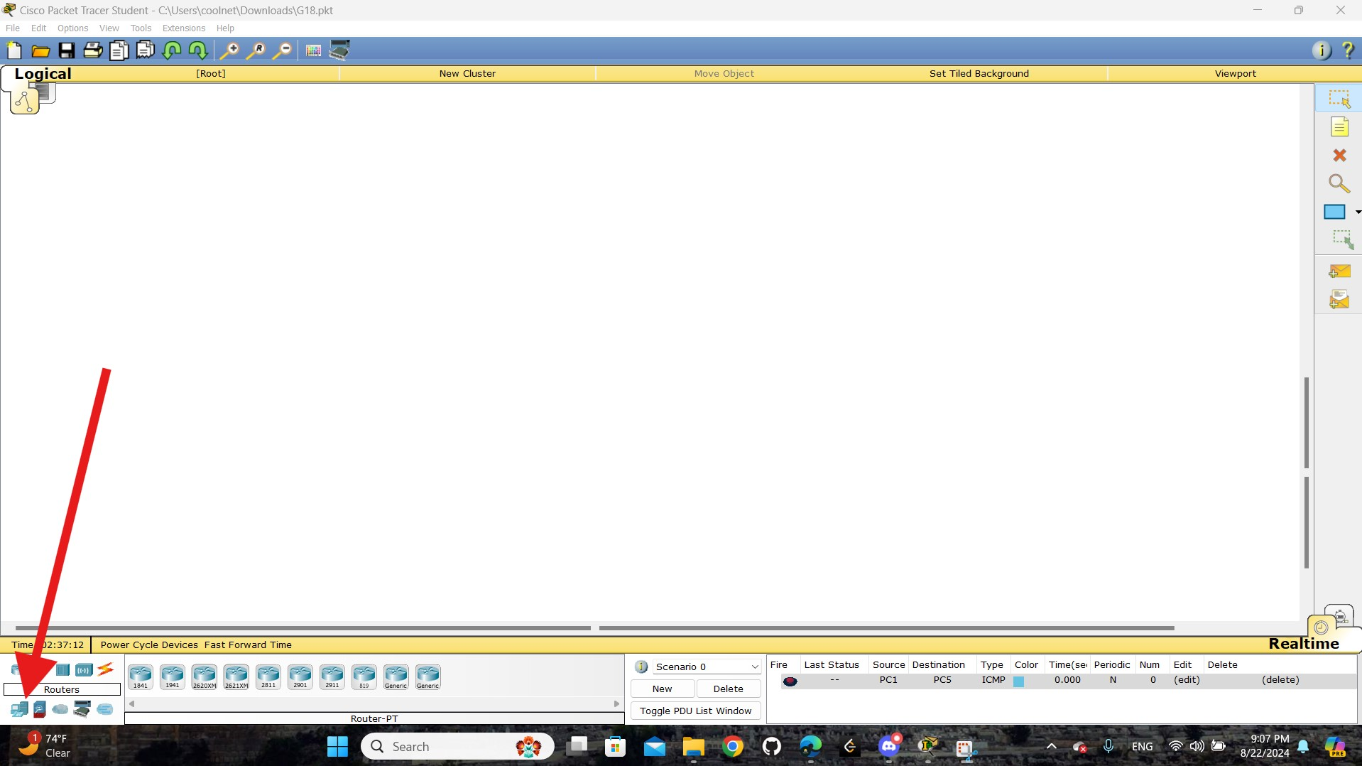

Figure : open end device tap

open ( end device ) tap

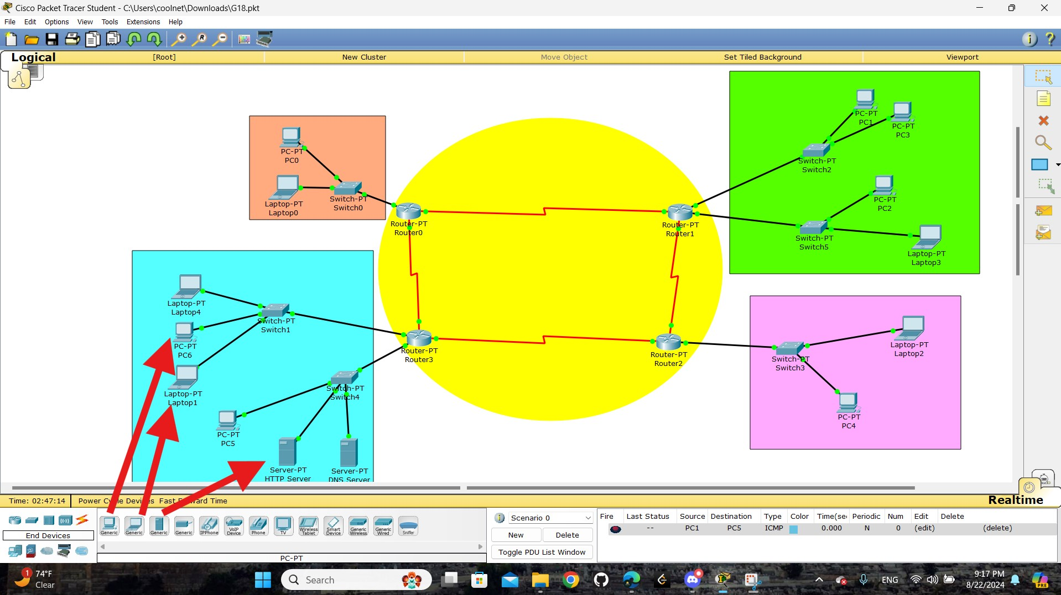

Figure : select and insert end device

select any ( end device ) and put it where are you want



Figure : Labtop0 IP Configuration



Figure : PC0 IP Configuration



Figure : Router0 - FastEthernet0/0



Figure : Labtop3 IP Configuration



Figure : PC1 IP Configuration



Figure : PC2 IP Configuration



Figure : PC3 IP Configuration



Figure : Router1 - FastEthernet0/0



Figure : Router1 - FastEthernet1/0



Figure : Labtop2 IP Configuration



Figure : PC4 IP Configuration



Figure : Router - FastEthernet0/0



Figure : DNS server IP Configuration



Figure : HTTP server IP Configuration



Figure : Labtop1 IP Configuration



Figure : Labtop4 IP Configuration



Figure : PC5 IP Configuration



Figure 41: PC6 IP Configuration



Figure : Router3 - FastEthernet0/0



Figure : Router3 - FastEthernet1/0

**how we set IP Addresses:**

- Click on a device.

- Go to the **Desktop** tab, select **IP Configuration**.

- Enter the IP address, subnet mask, and gateway.

## Part2:

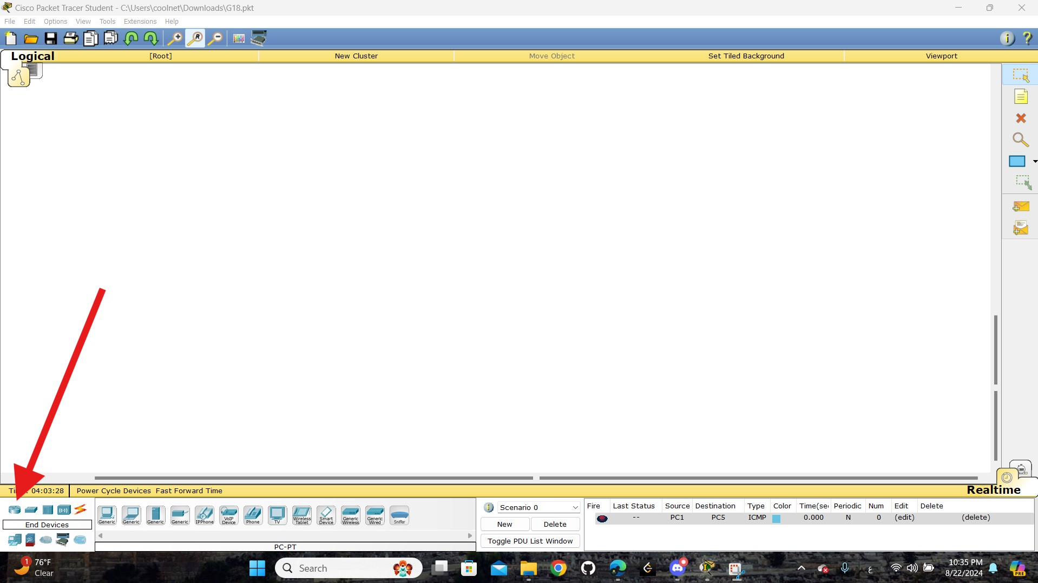

Figure : open router tap

open ( router ) tap

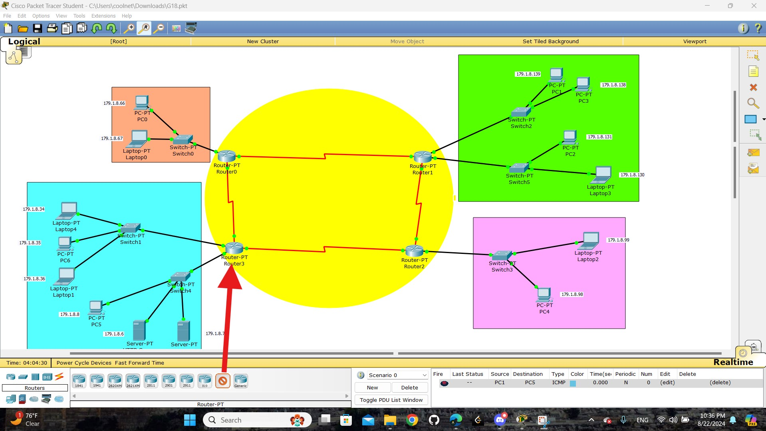

Figure : select and insert router

select general ( router ) and put it where are you want

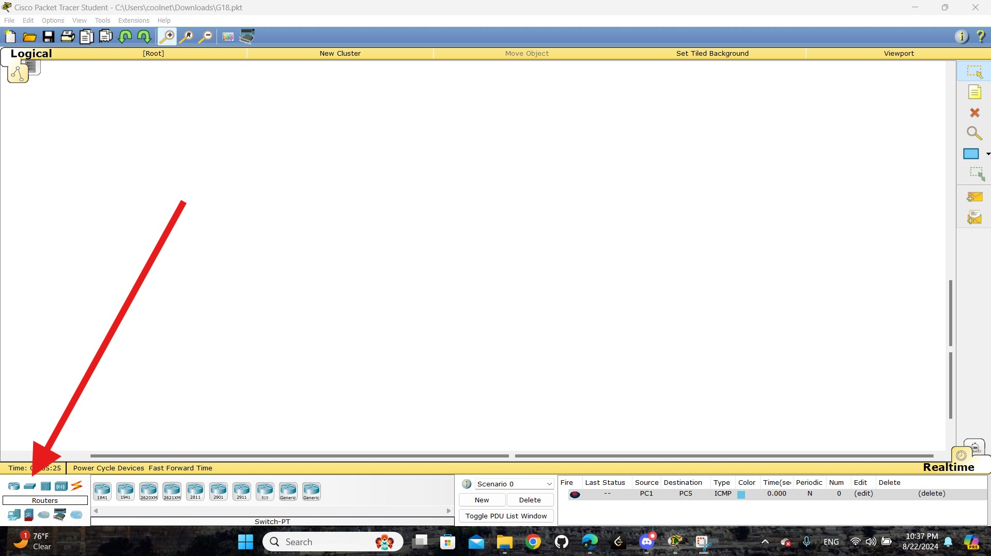

Figure : open switch tap

open ( switch) tap

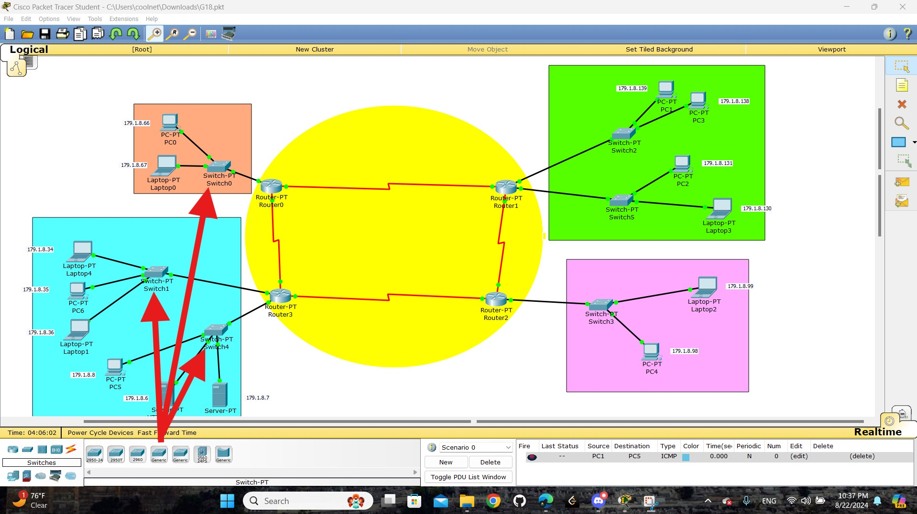

Figure : select and insert switch

select general ( switch ) and put it where are you want

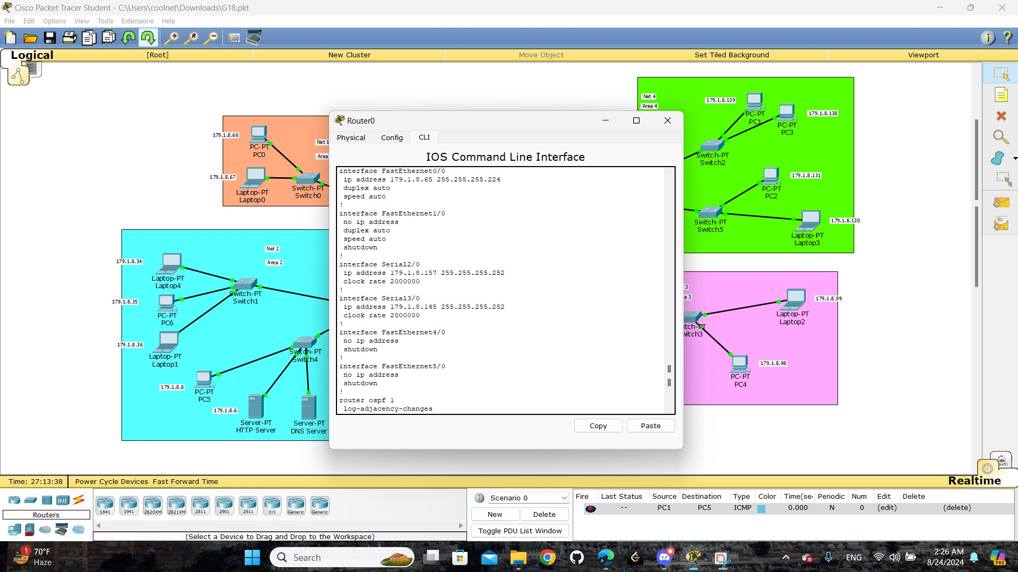

Figure 48: Router0 - IOS Command

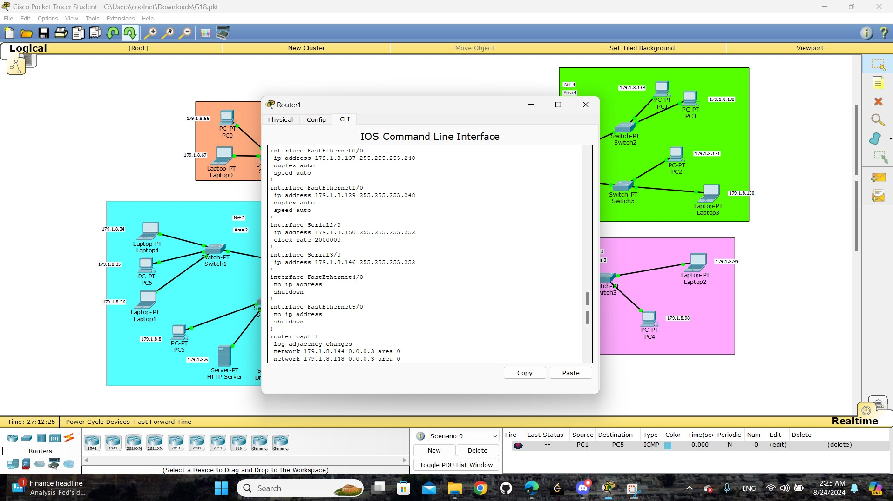

Figure : Router1 - IOS Command

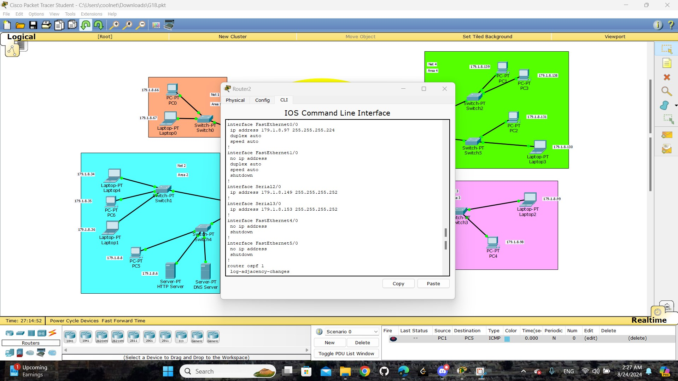

Figure : Router2 - IOS Command

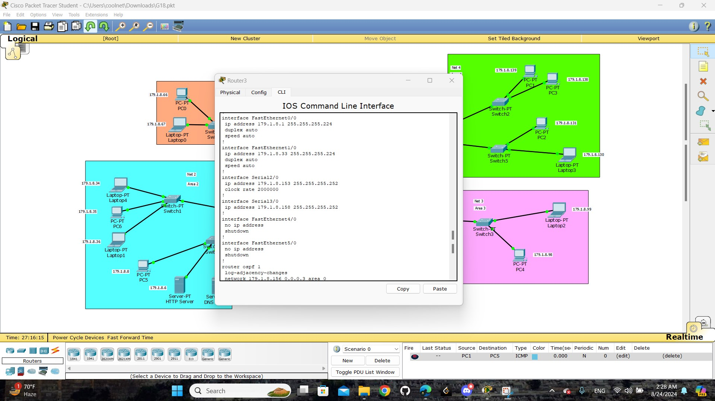

Figure : Router3 - IOS Command

The images show the configuration of a router in Packet Tracer. The router's interfaces are set up with specific IP addresses: **ex:** “ `FastEthernet0/0` with `179.1.8.97/27` and `Serial2/0` with `179.1.8.149/30` “. The `no shutdown` command is used to activate them. Additionally, OSPF routing is configured to manage the network, with a command to log changes in OSPF neighbor relationships. This setup connects different network segments, enabling communication across them.

## Part3:



Figure : IPs in topology

This is a final image of the IP distribution on the devices.

# Task 2:

## part 1:

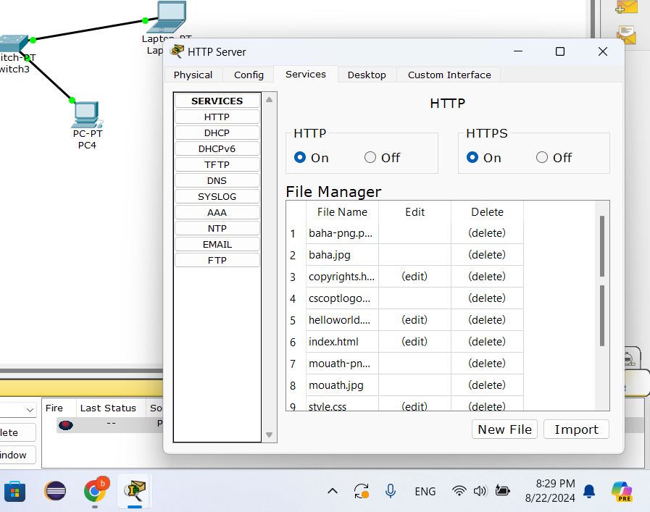

Figure : HTTP server – File Manager

Here we have the HTTP server and it is on , and the file manager window shows a list of files and folders

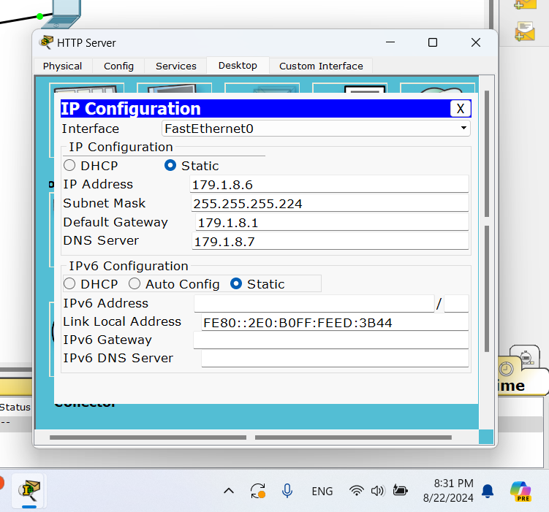

Figure : HTTP server IP Configuration

Here we have IP address , Subnet Mask , Default Gateway , DNS Server for HTTP server

## part 2:

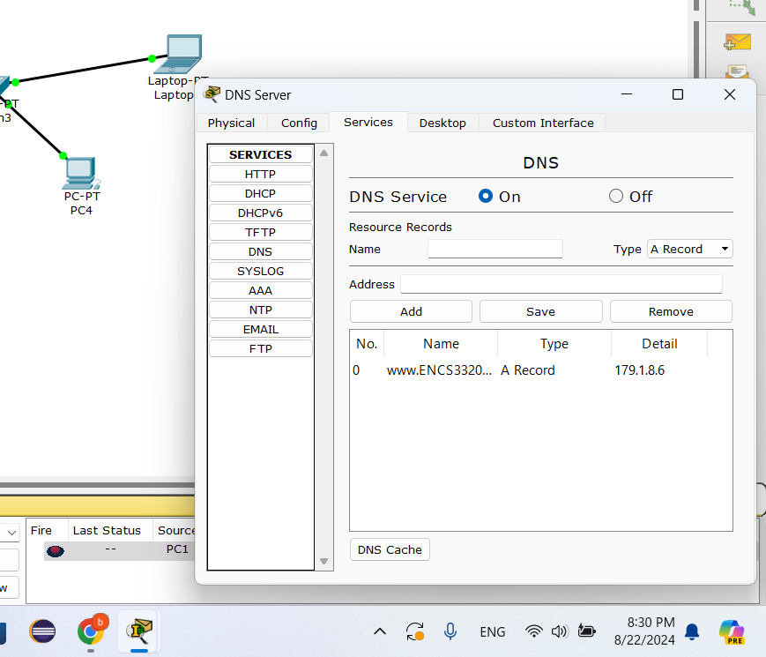

Figure : DNS server - File Manager

Here we have the DNS server and it is on , and we have the the domain name www.ENCS3320Summer.com

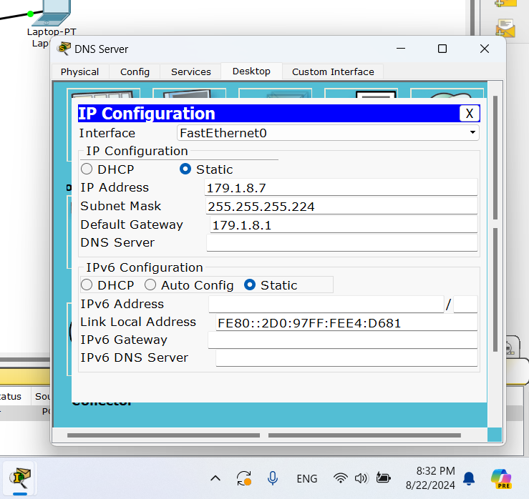

Figure : DNS server IP Configuration

Here we have IP Address , Subnet Mask , Default Gateway for DNS server

## Part 3:

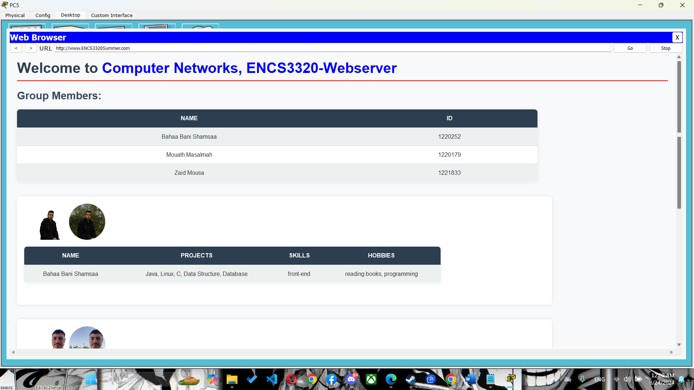

Figure 57: PC5 Web Brawser

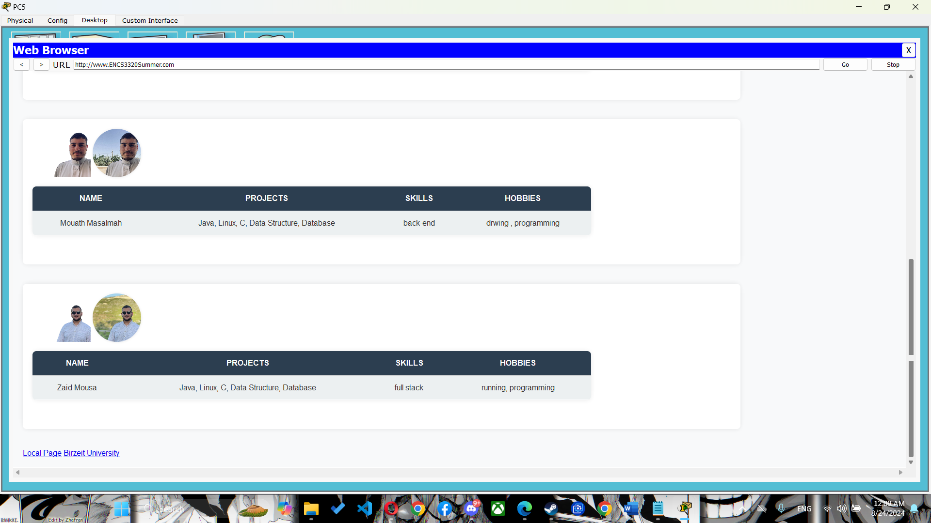

Figure : PC5 Web Brawser

# Task 3:

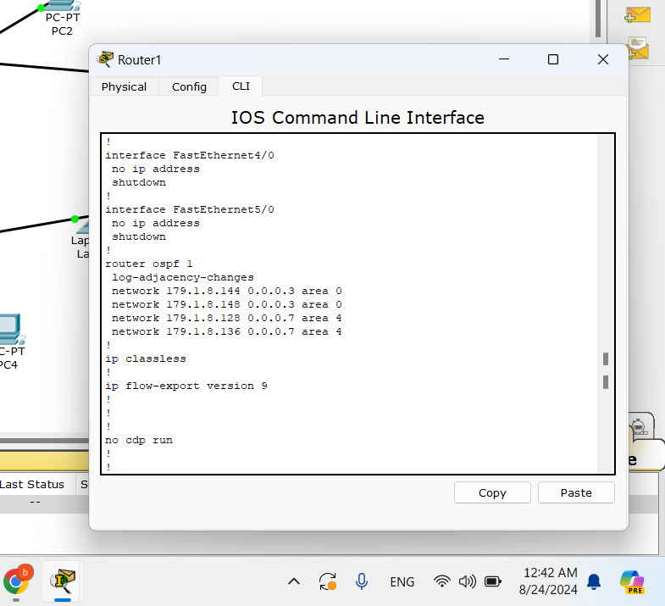

Figure : Router1 ospf

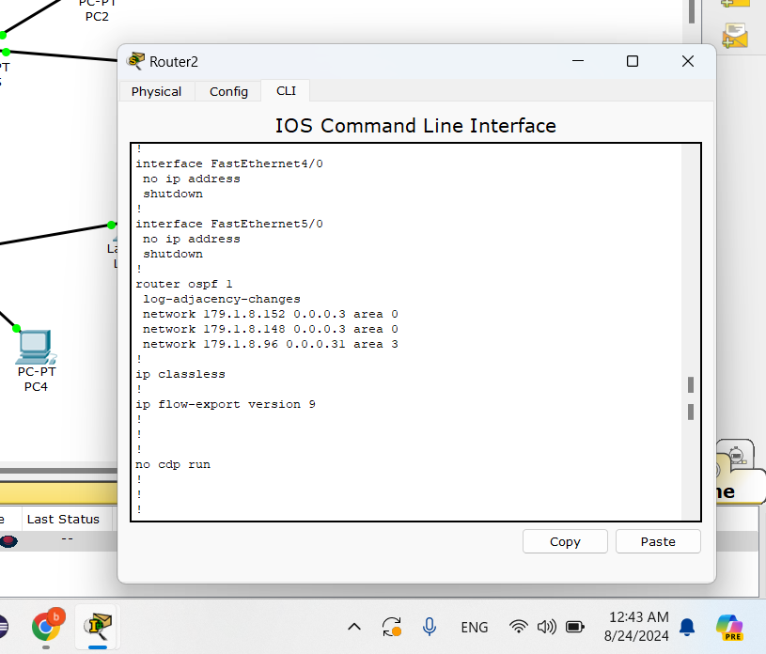

Figure : Router2 ospf

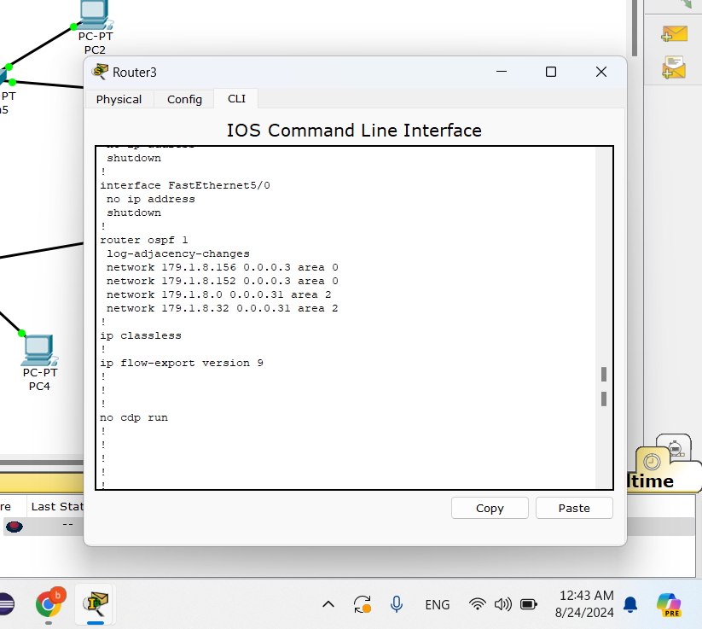

Figure : Router3 ospf

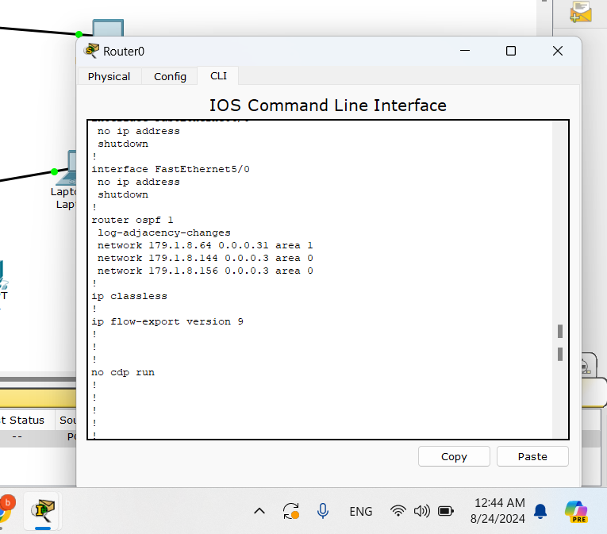

Figure : Router0 ospf

Open Shortest Path First (OSPF) is a routing protocol that helps routers find the best path to send data. It's smart, fast, and works well in large networks.

To use OSPF:

**Start OSPF:**

* Go to the router’s configuration mode and start OSPF by giving it a number (process ID).

**Add Networks to OSPF:**

* Tell OSPF which networks to manage and in which area they belong.

**(Optional) Set Router ID:**

* Assign a unique ID to your router to identify it in the network.

Commands:

router ospf 1

log-adjacency-changes

network 179.1.8.144 0.0.0.3 area 0

network 179.1.8.148 0.0.0.3 area 0

network 179.1.8.128 0.0.0.7 area 4

network 179.1.8.136 0.0.0.7 area 4

router ospf 1

log-adjacency-changes

network 179.1.8.152 0.0.0.3 area 0

network 179.1.8.148 0.0.0.3 area 0

network 179.1.8.96 0.0.0.31 area 3

router ospf 1

log-adjacency-changes

network 179.1.8.64 0.0.0.31 area 1

network 179.1.8.144 0.0.0.3 area 0

network 179.1.8.156 0.0.0.3 area 0

router ospf 1

log-adjacency-changes

network 179.1.8.156 0.0.0.3 area 0

network 179.1.8.152 0.0.0.3 area 0

network 179.1.8.0 0.0.0.31 area 2

network 179.1.8.32 0.0.0.31 area 2

# Task 4:

## part 1:

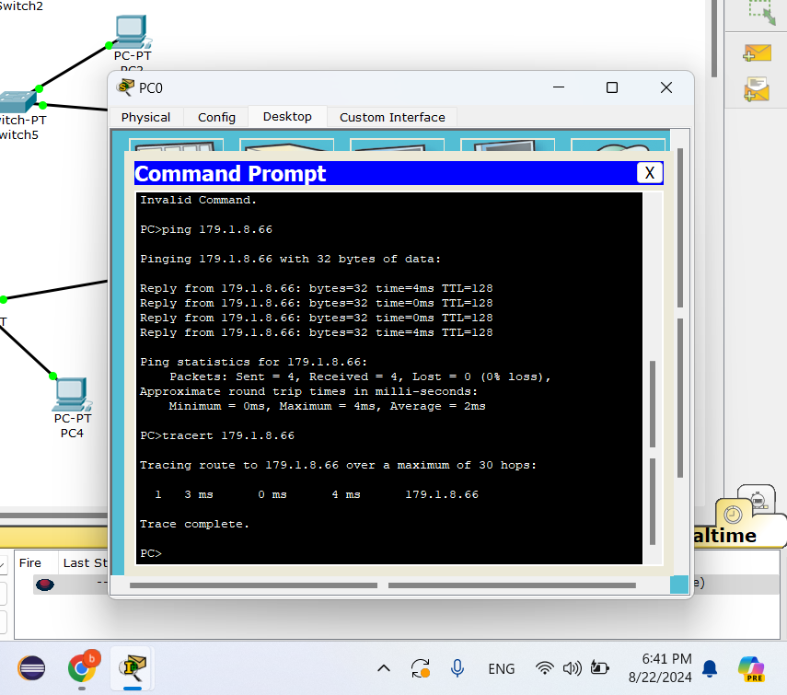

Figure : PC0 tracert and ping

Tracert and ping for PC0 with ip 179.1.8.66 and it works as shown in picture

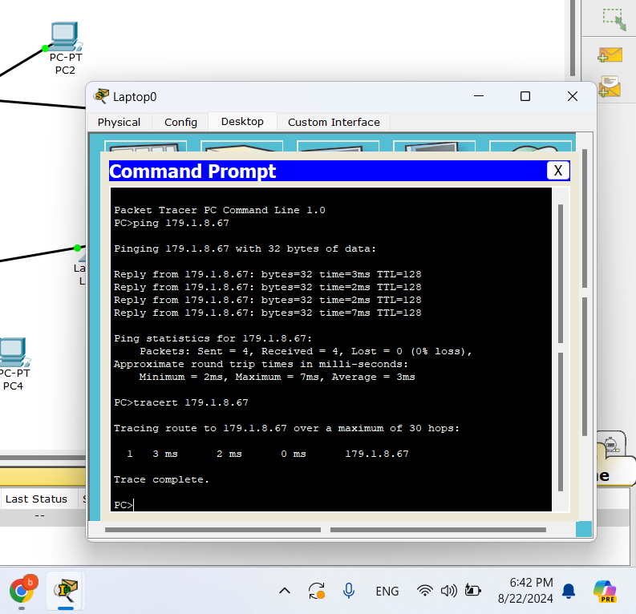

Figure : Labtop0 tracert and ping

Tracert and ping for Laptop0 with ip 179.1.8.67 and it works as shown in picture

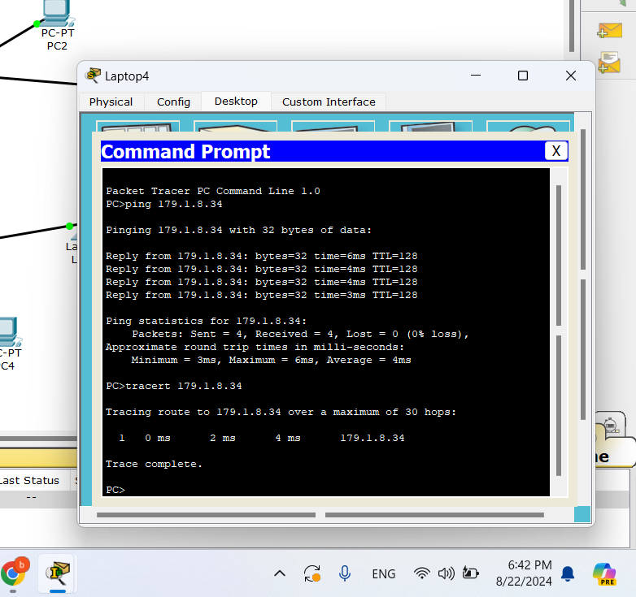

Figure : Labtop4 tracert and ping

Tracert and ping for Laptop4 with ip 179.1.8.34 and it works as shown in picture

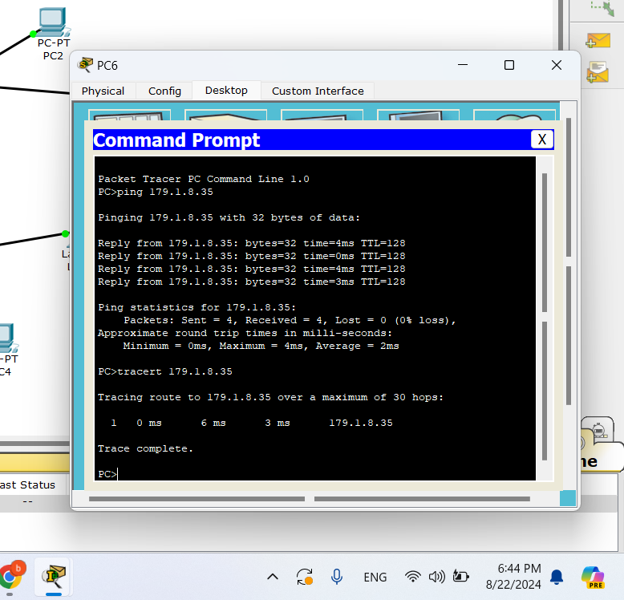

Figure : PC6 tracert and ping

Tracert and ping for PC6 with ip 179.1.8.35 and it works as shown in picture

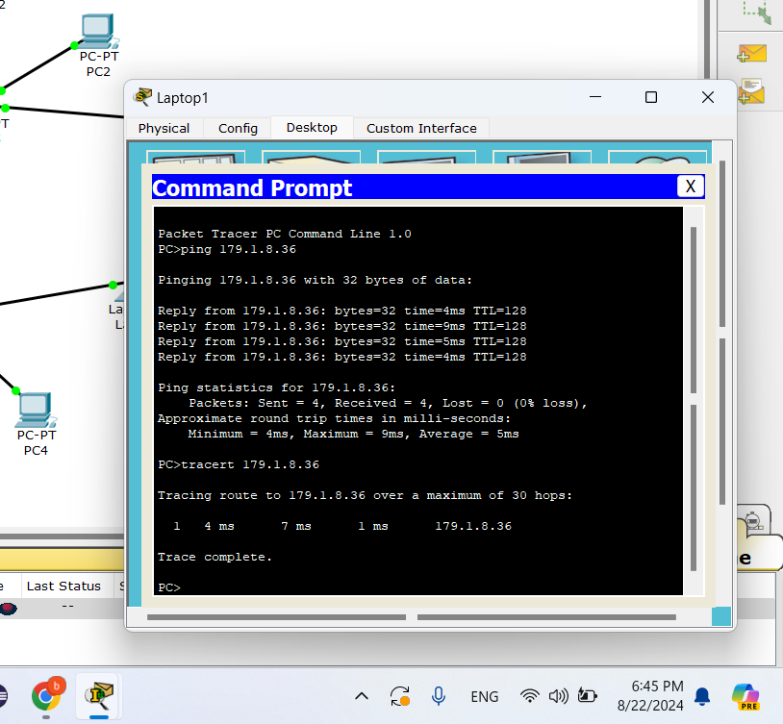

Figure : Labtop1 tracert and ping

Tracert and ping for Laptop1 with ip 179.1.8.36 and it works as shown in picture

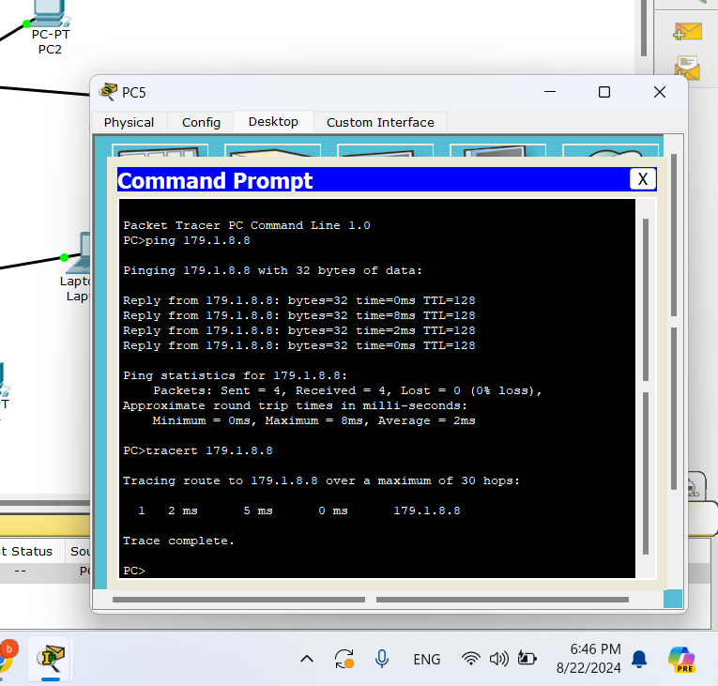

Figure : PC5 tracert and ping

Tracert and ping for PC5 with ip 179.1.8.8 and it works as shown in picture

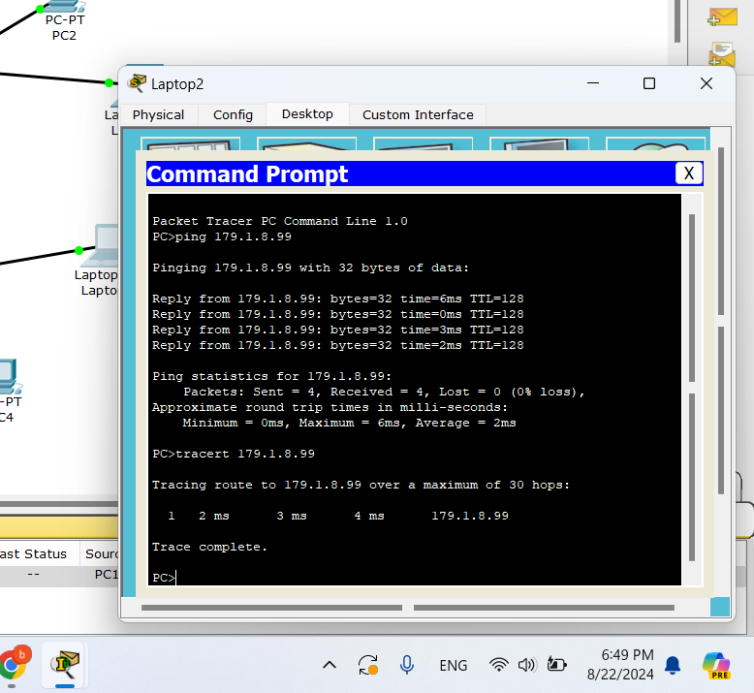

Figure : Labtop2 tracert and ping

Tracert and ping for Laptop2 with ip 179.1.8.99 and it works as shown in picture

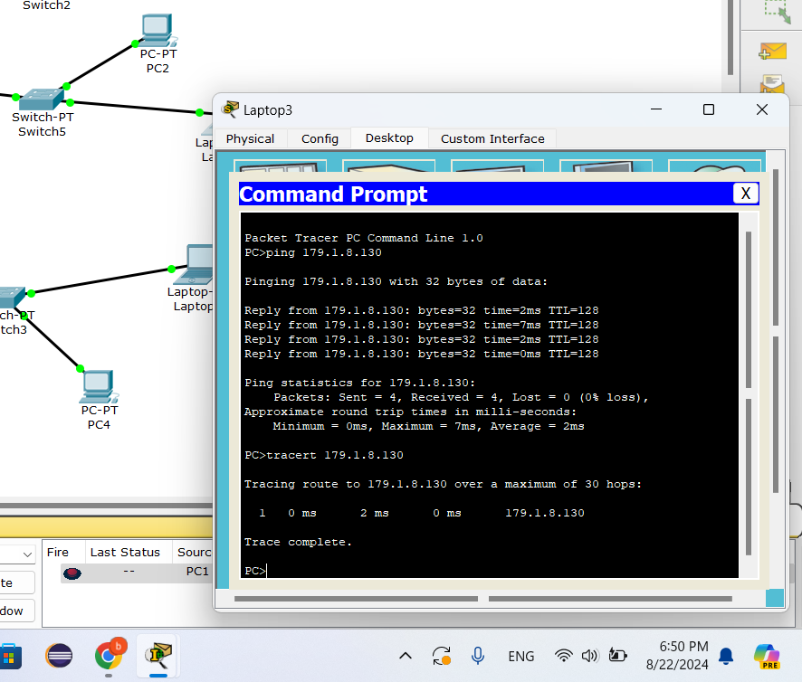

Figure : Labtop3 tracert and ping

Tracert and ping for Laptop3 with ip 179.1.8.130 and it works as shown in picture



Figure : Labtop3 tracert and ping

Tracert and ping for Laptop3 with ip 179.1.8.130 and it works as shown in picture

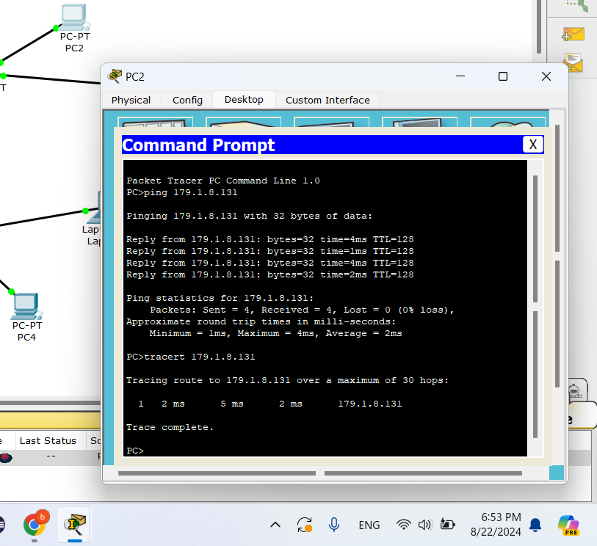

Figure : PC2 tracert and ping

Tracert and ping for PC2 with ip 179.1.8.131 and it works as shown in picture

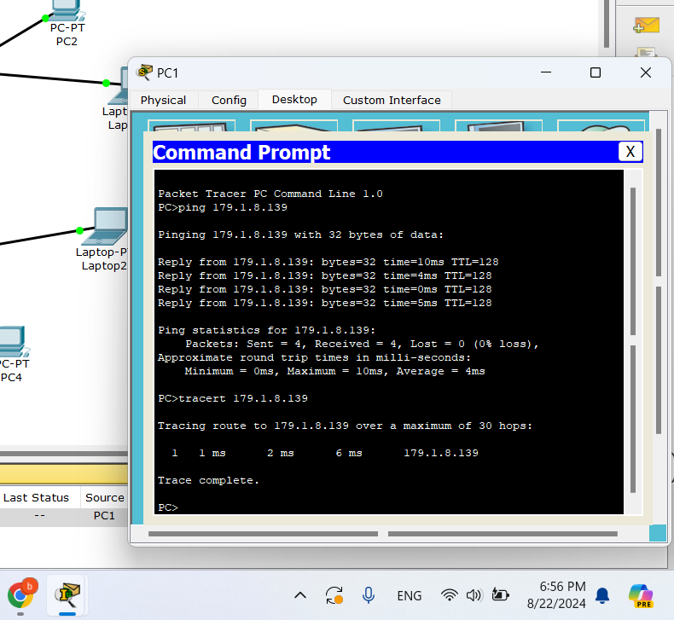

Figure : PC1 tracert and ping

Tracert and ping for PC1 with ip 179.1.8.139 and it works as shown in picture

## part 2:

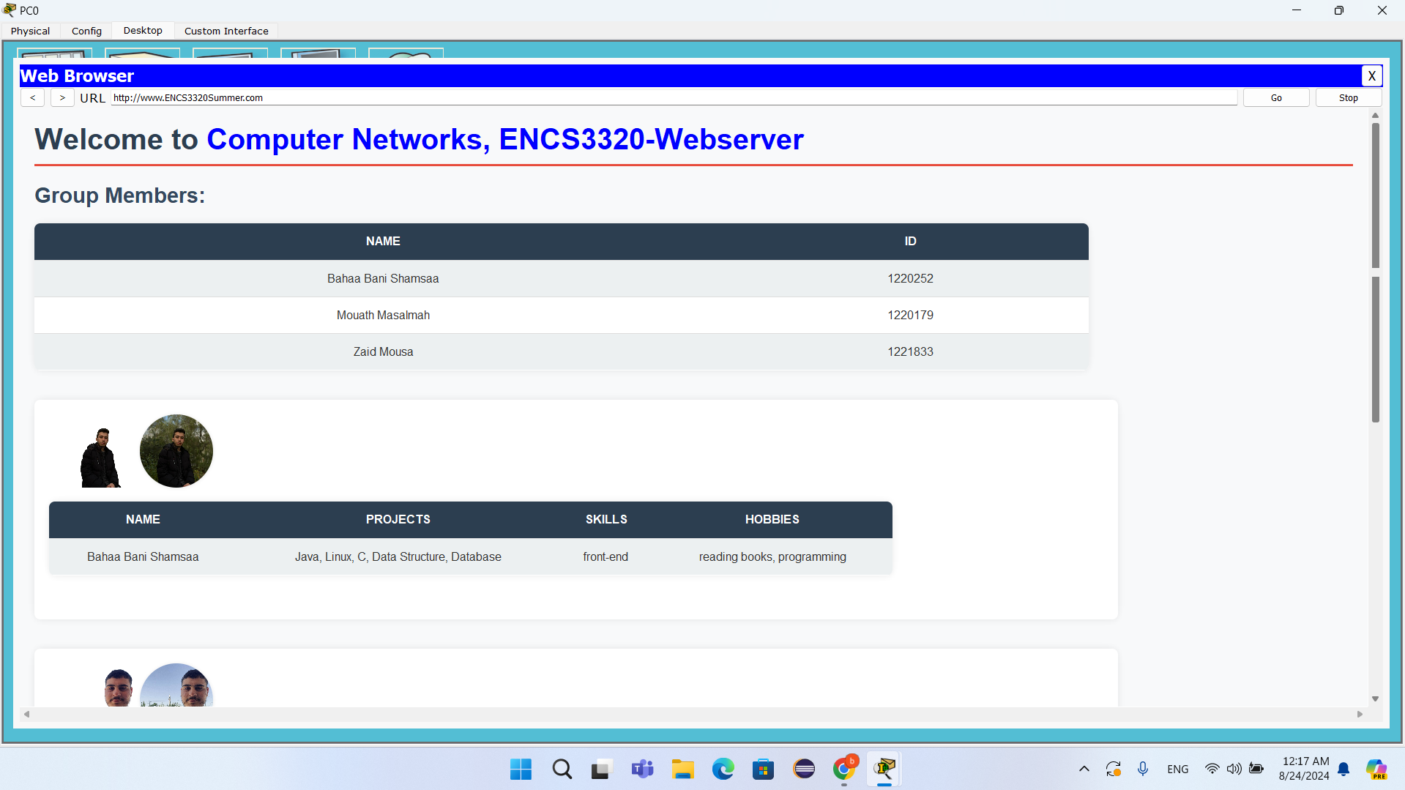

Figure : PC0 Web Page

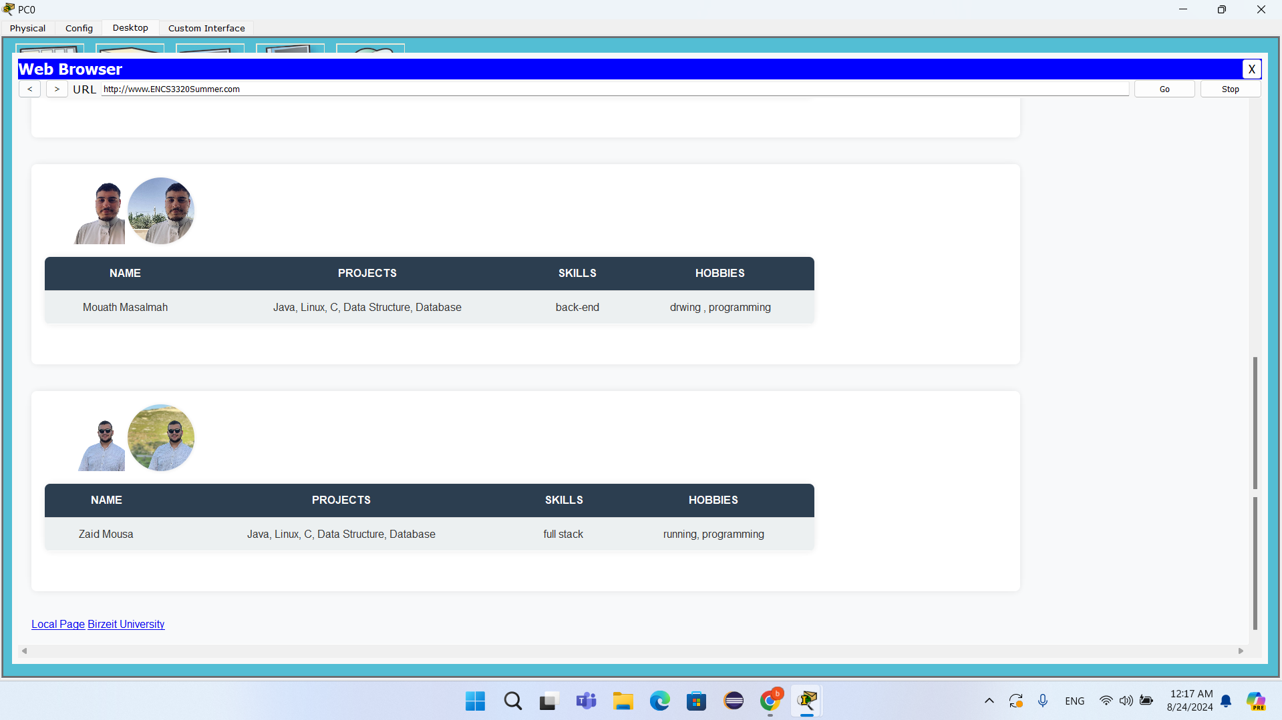

Figure : PC0 Web Page

web page for PC0

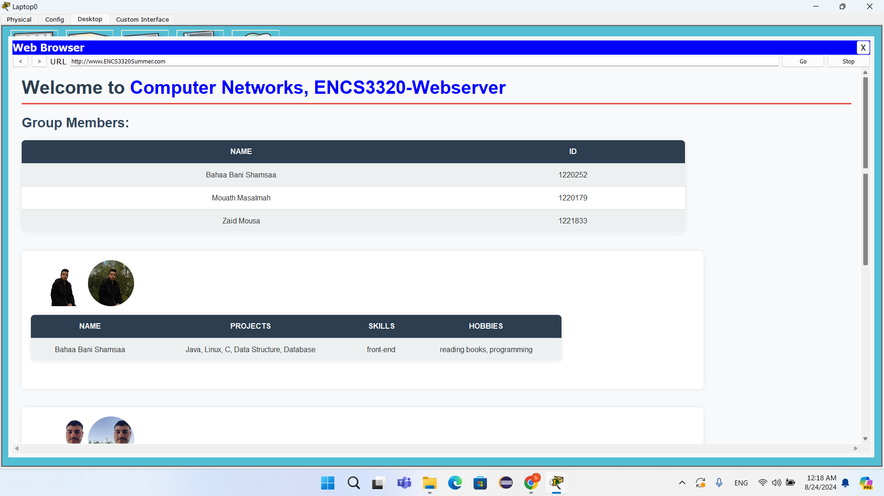

Figure : Labtop0 Web Page

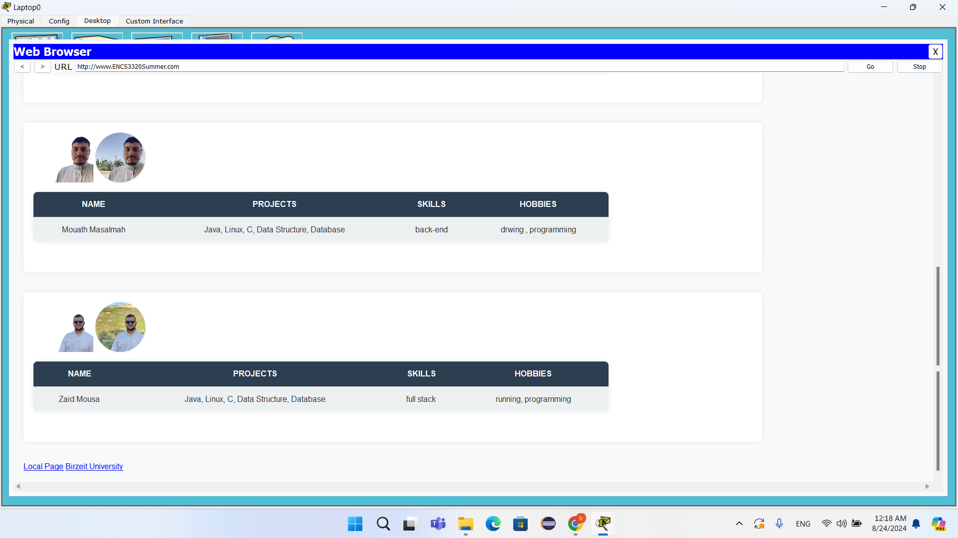

Figure : Labtop0 Web Page

web page for Laptop0

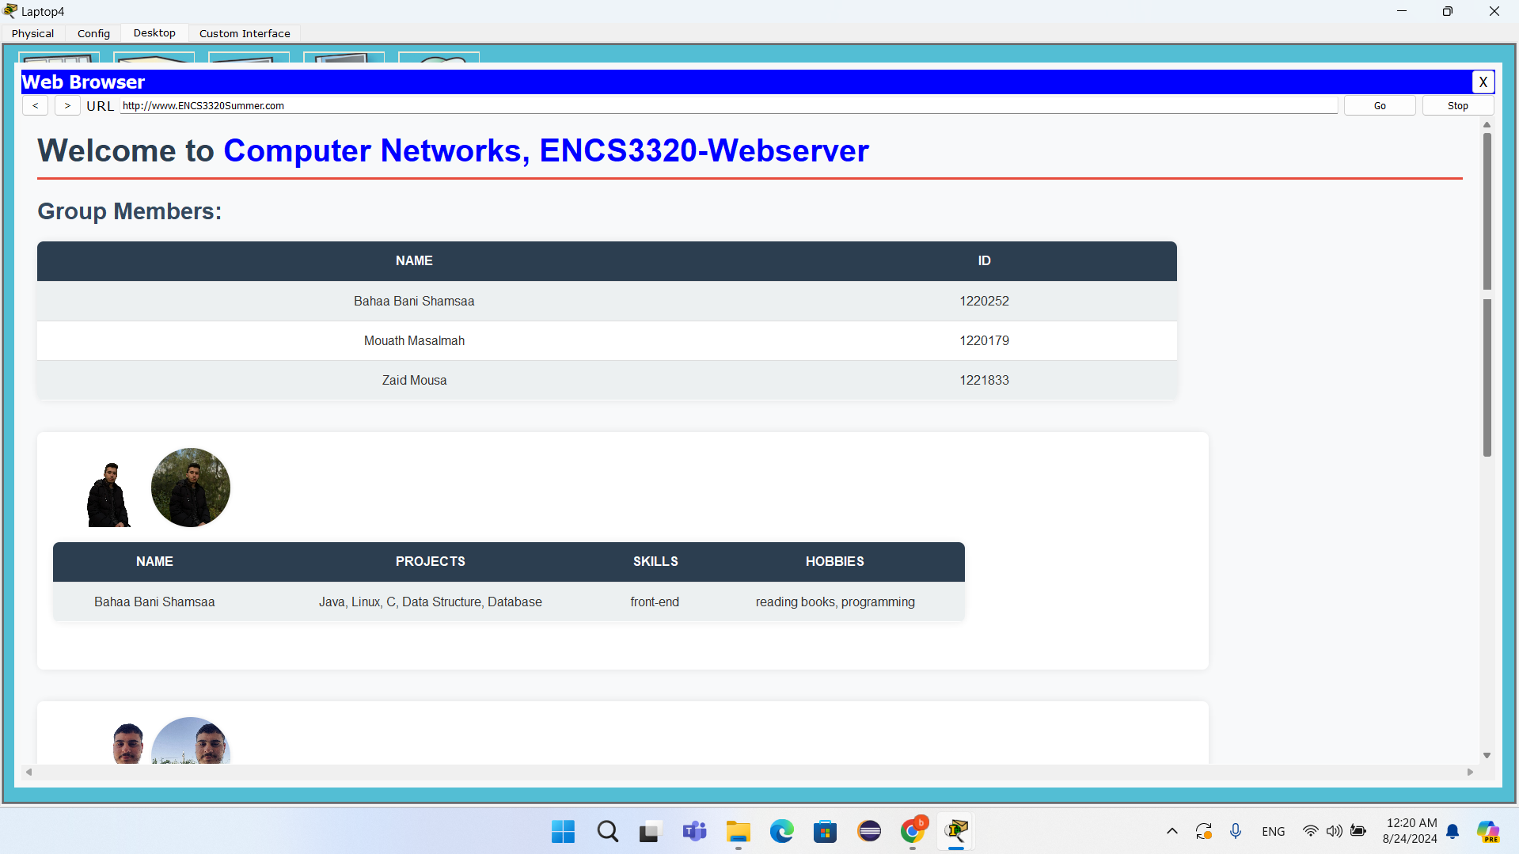

Figure : Labtop4 Web Page

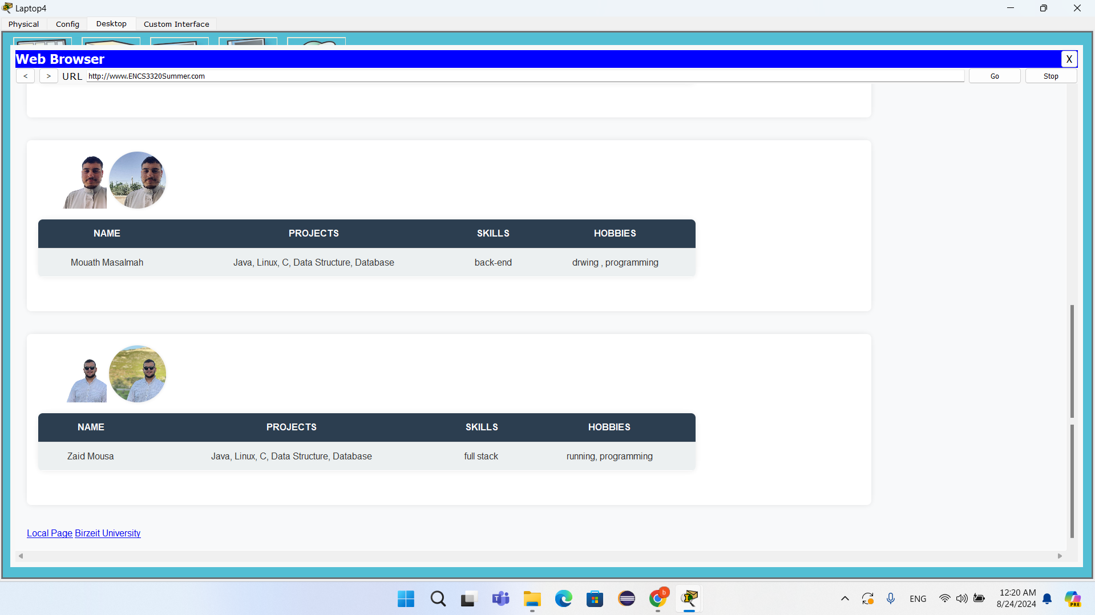

Figure : Labtop4 Web Page

web page for Laptop4

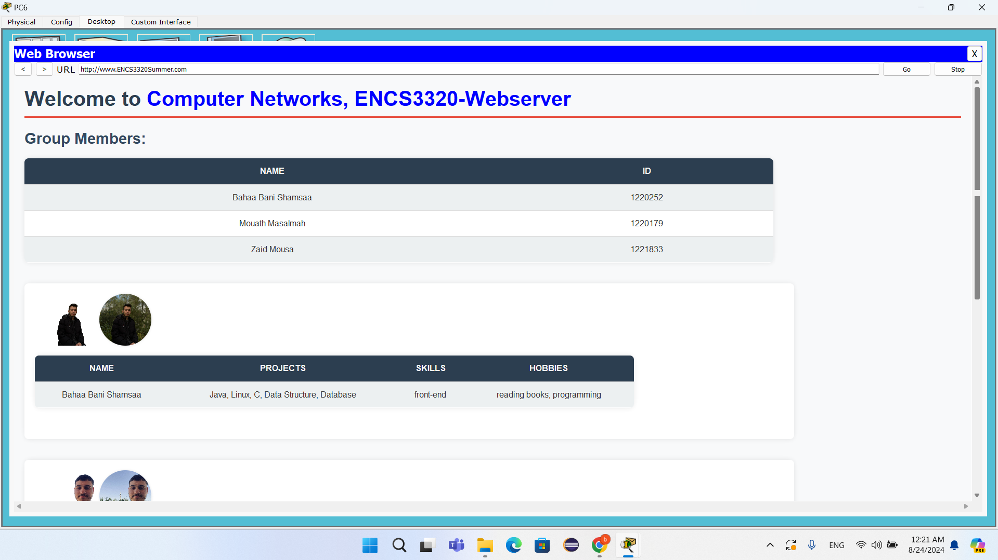

Figure : PC6 Web Page

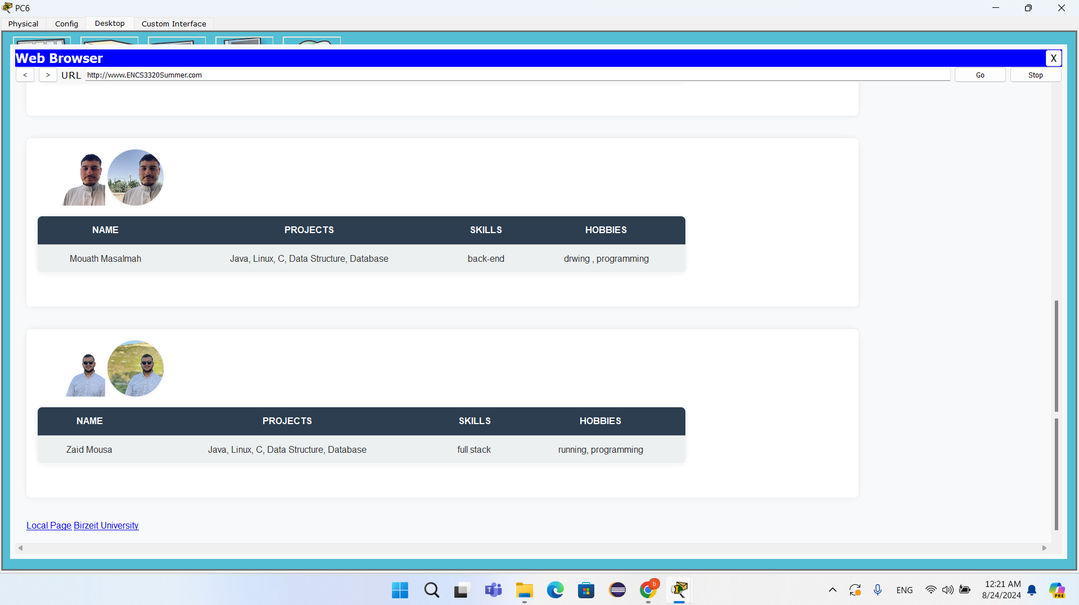

Figure : PC6 Web Page

web page for PC6

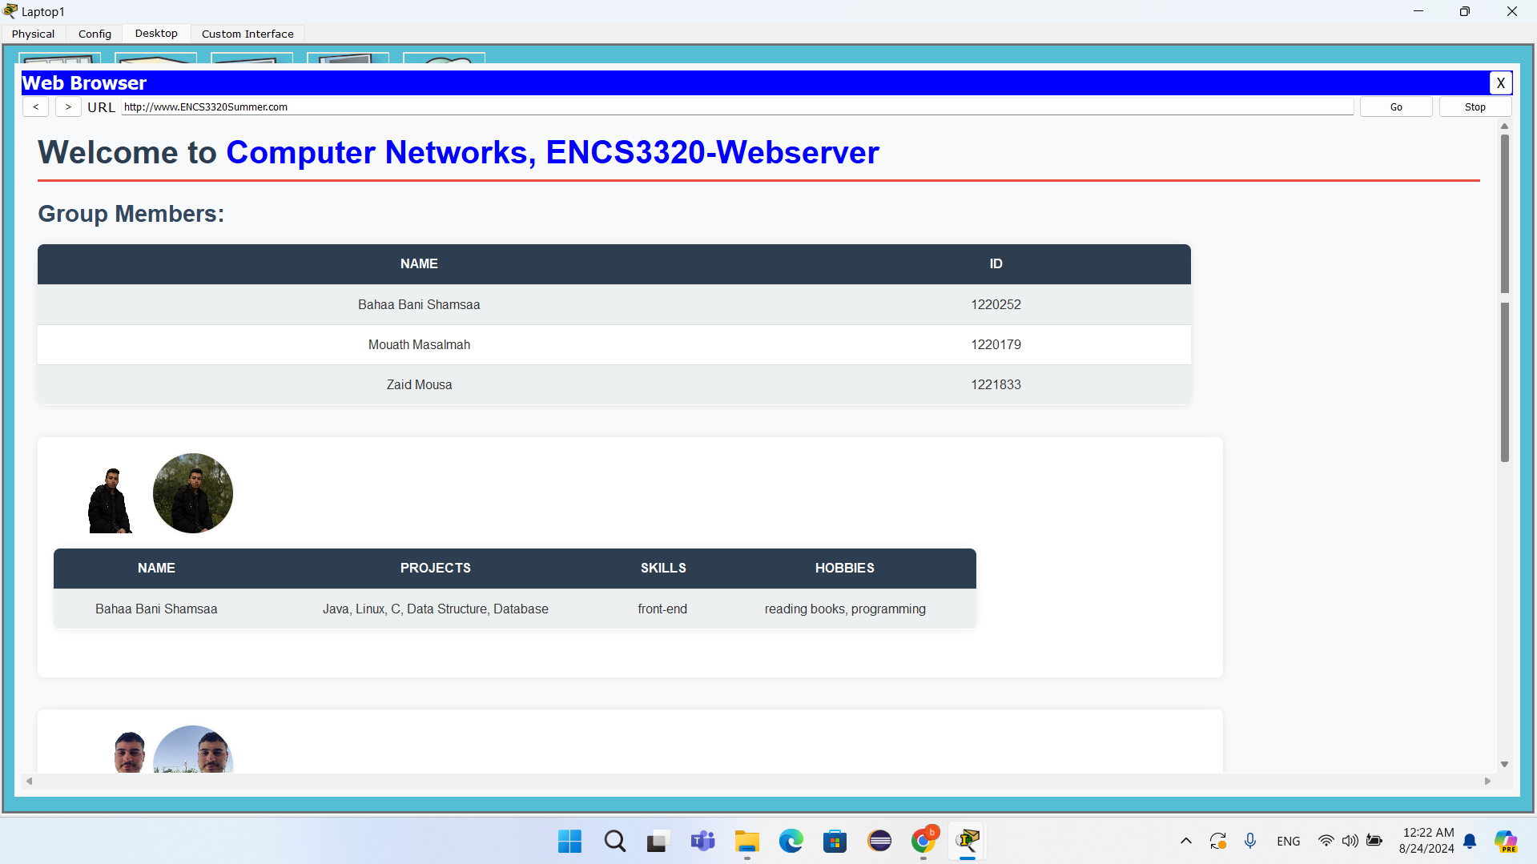

Figure : Labtop1 Web Page

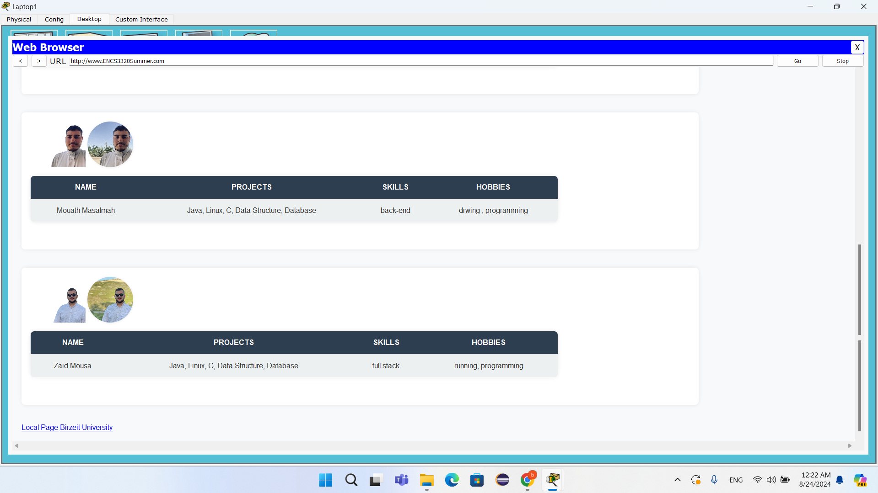

Figure : Labtop1 Web Page

web page for Laptop1

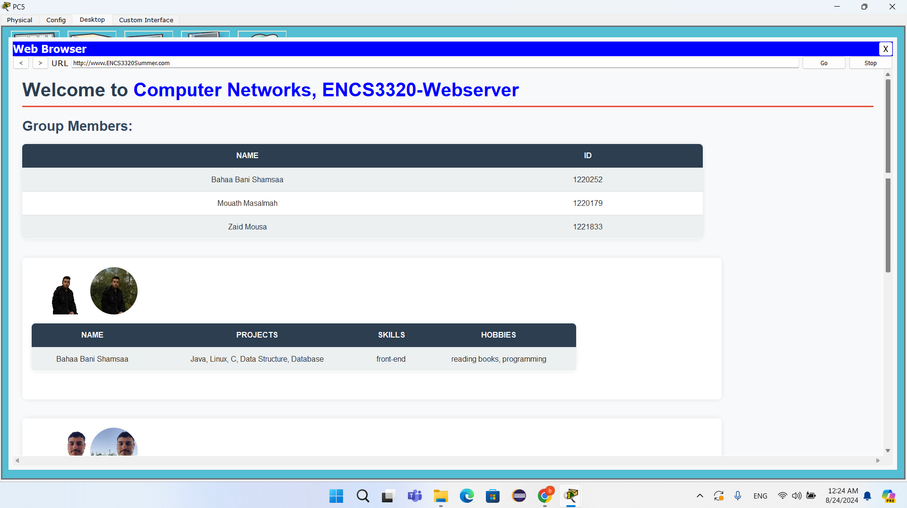

Figure : PC5 Web Page

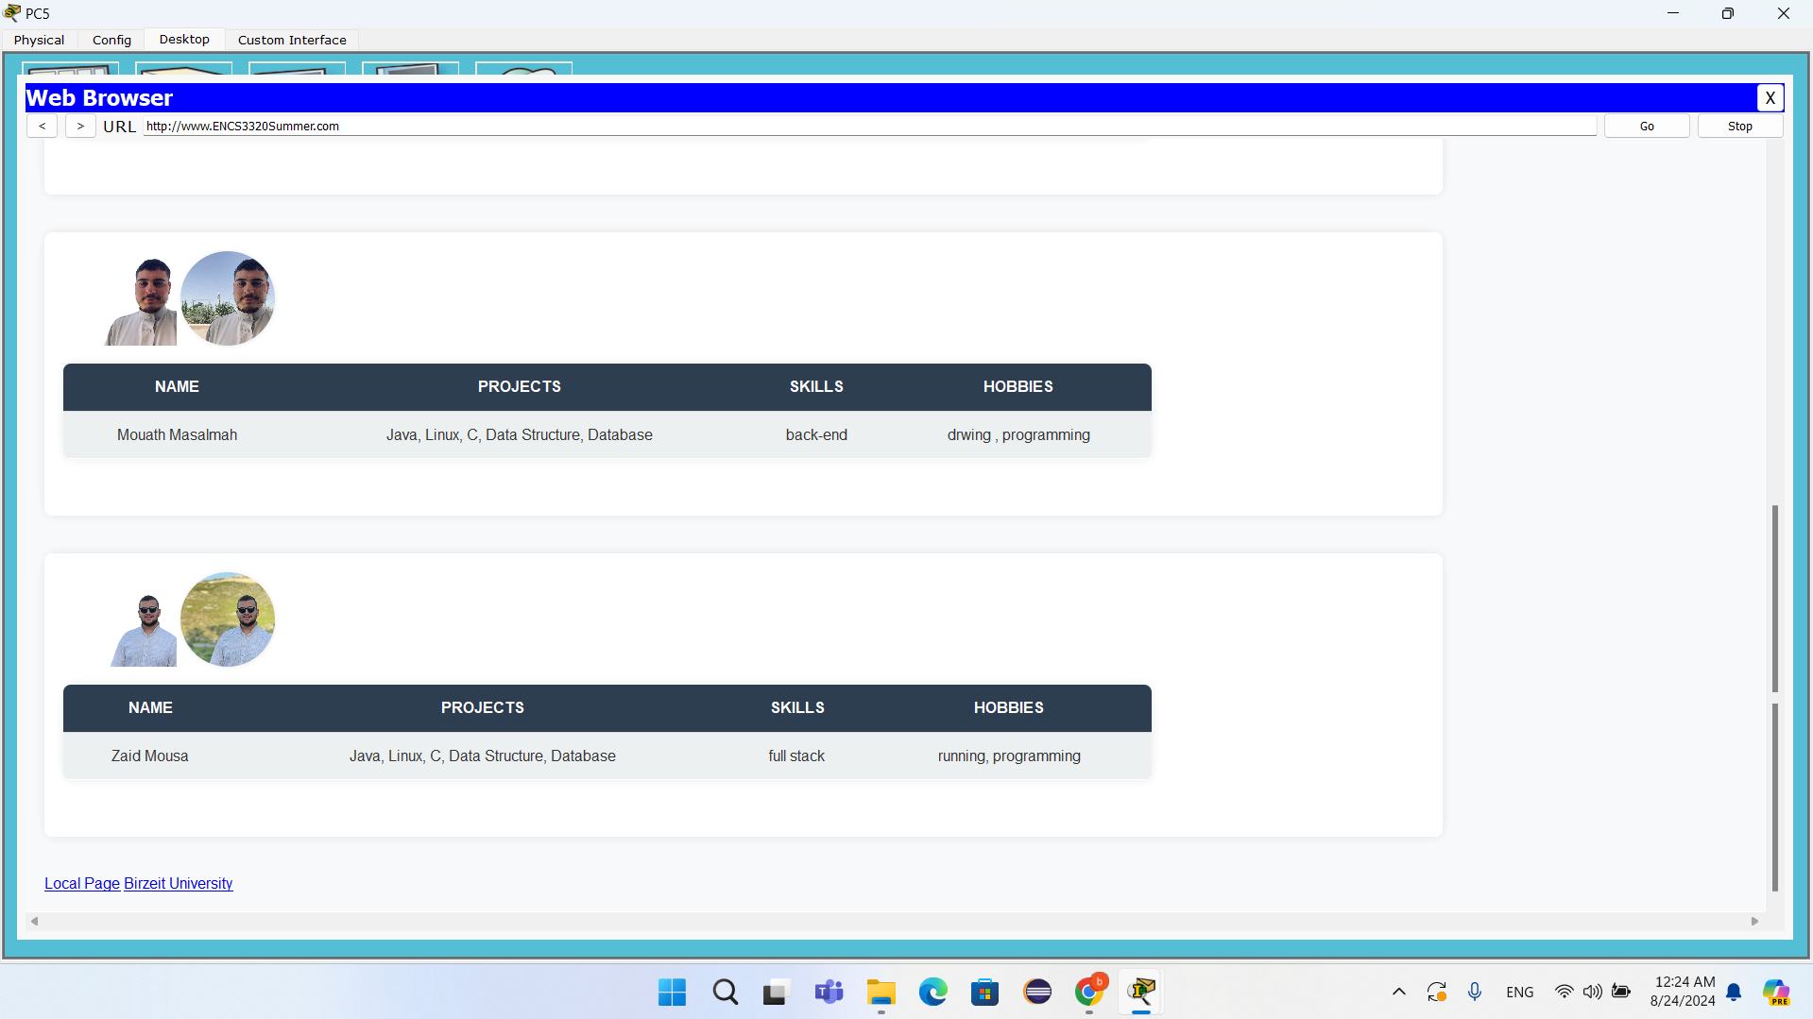

Figure : PC5 Web Page

web page for PC5

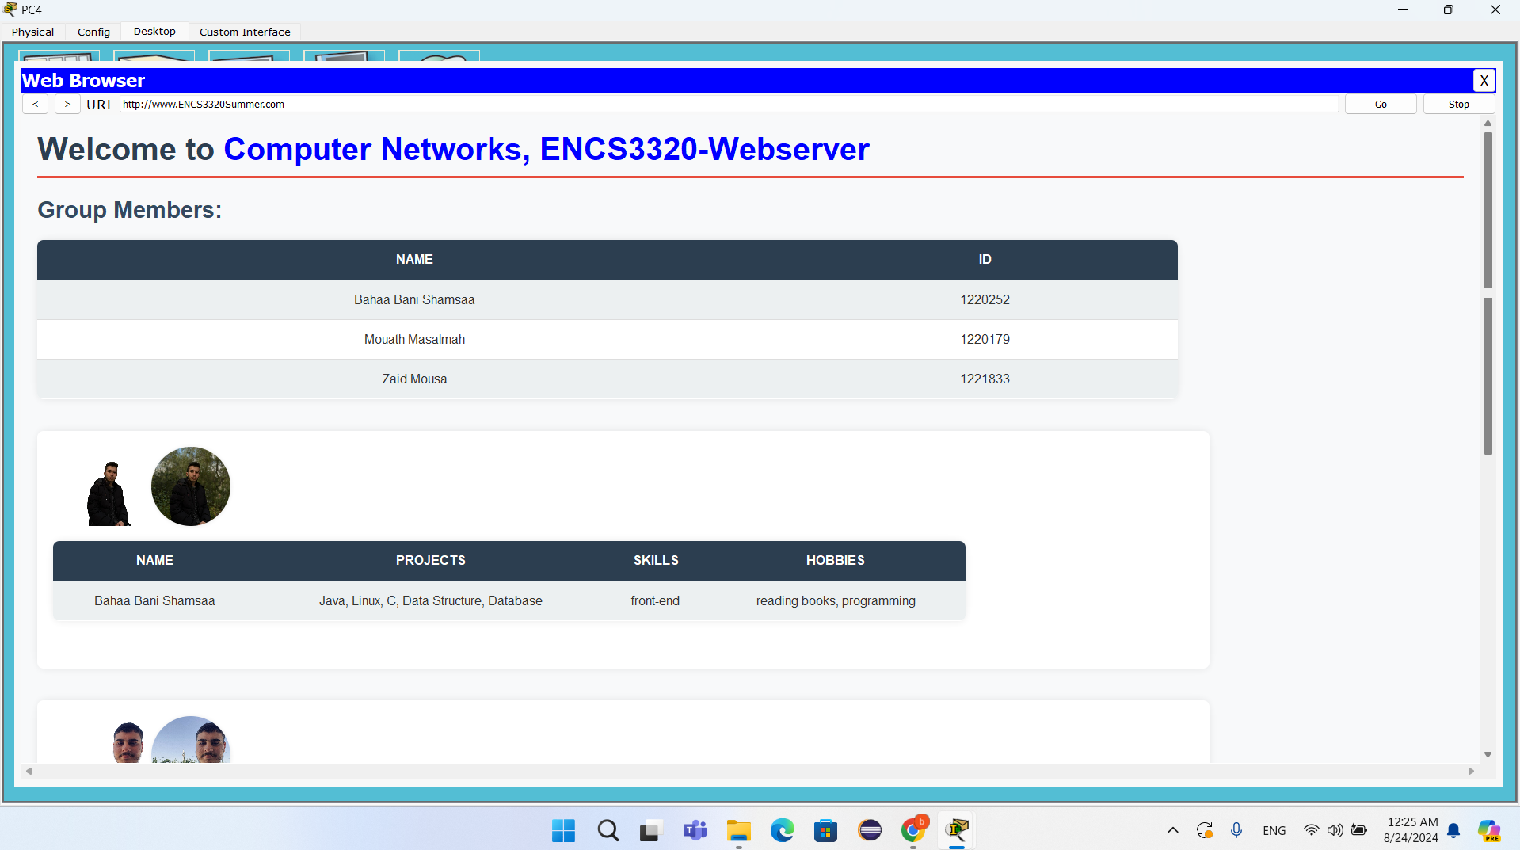

Figure : PC4 Web Page

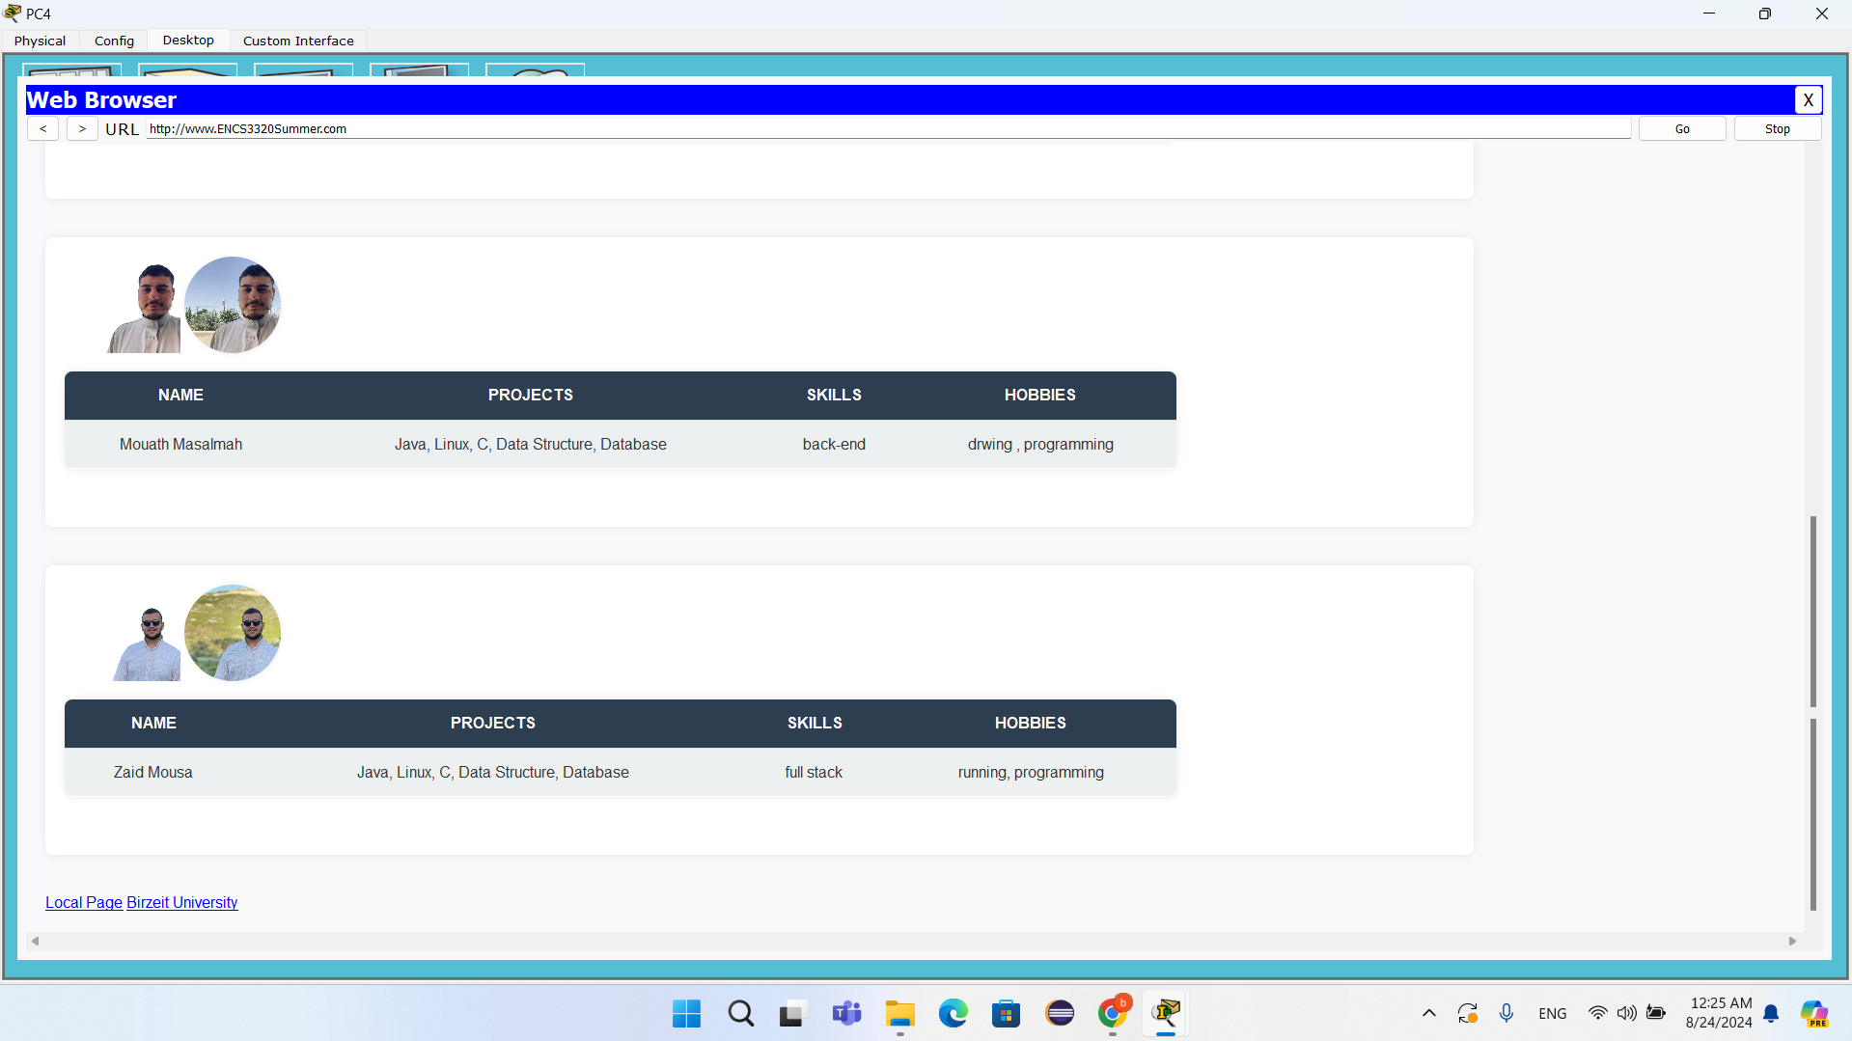

Figure : PC4 Web Page

web page for PC4

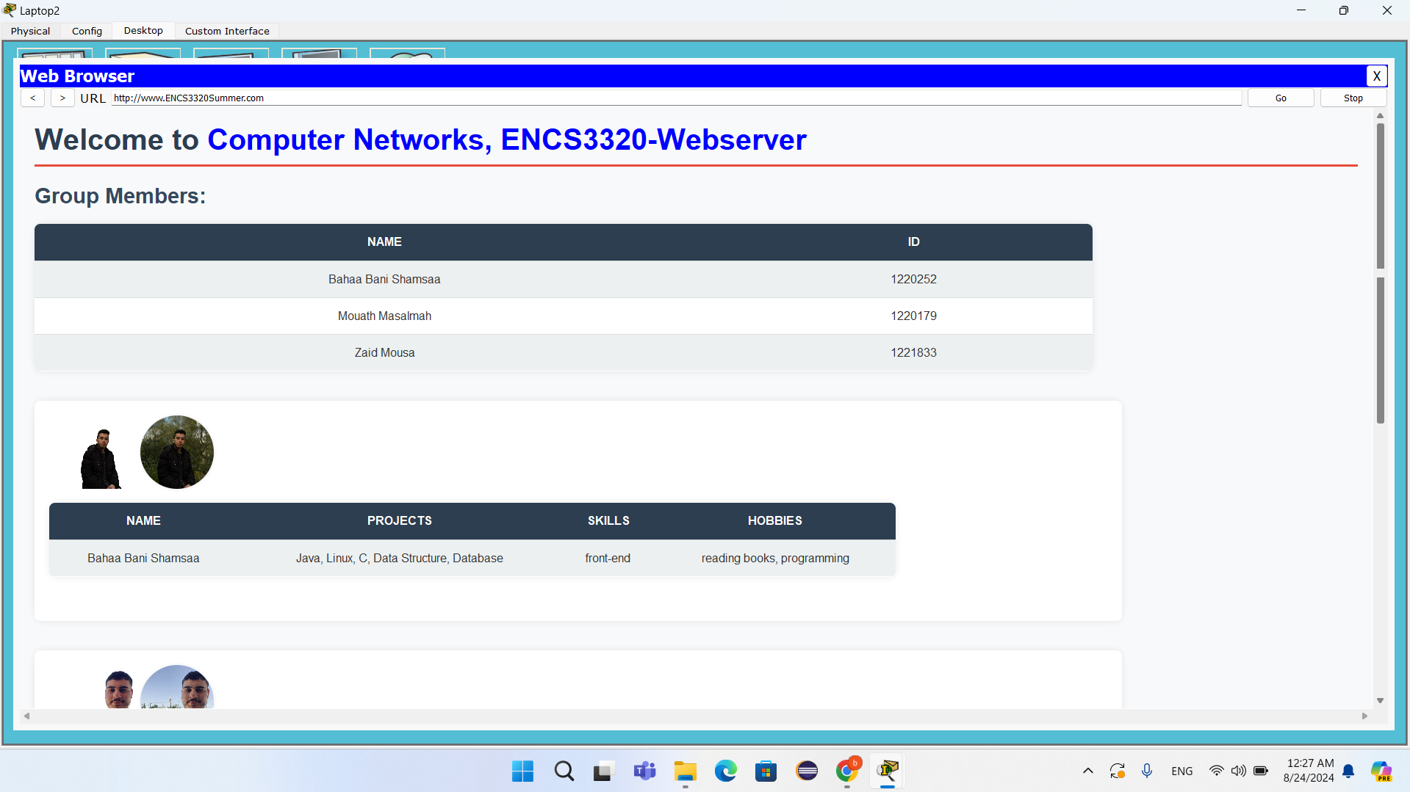

Figure : Labtop2 Web Page

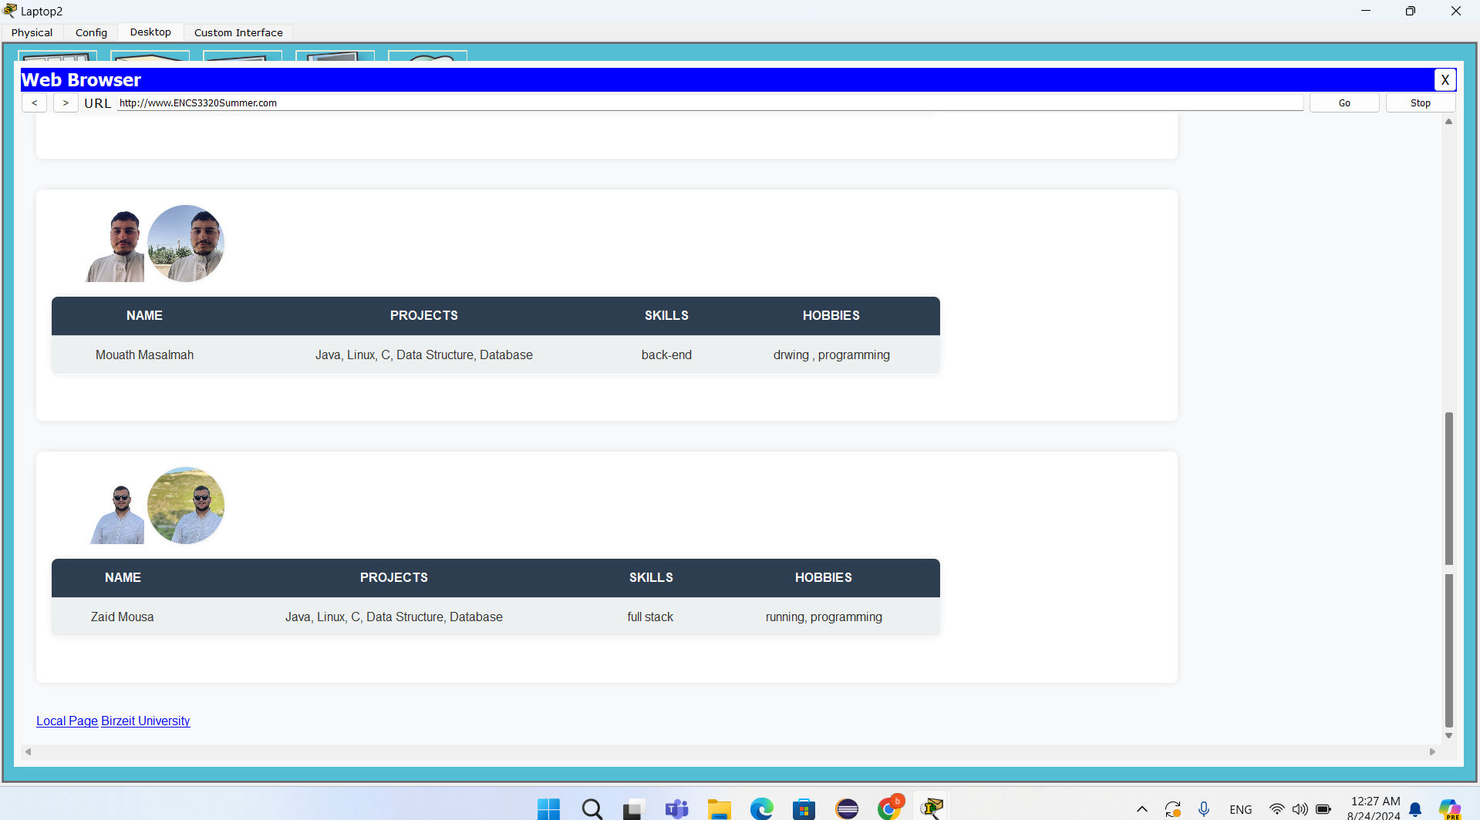

Figure : Labtop2 Web Page

web page for Laptop2

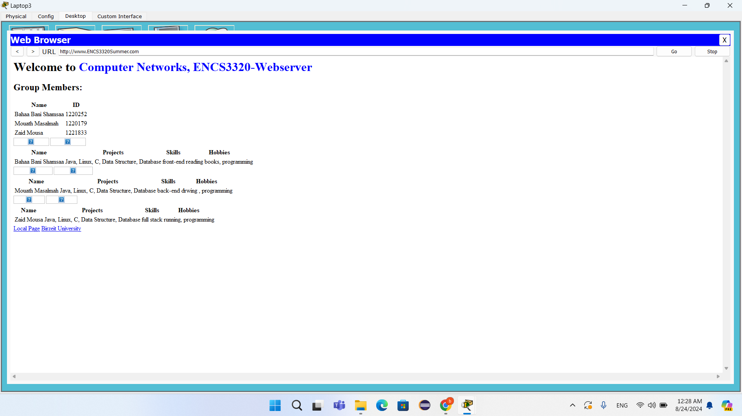

Figure : Labtop3 Web Page

web page for Laptop3

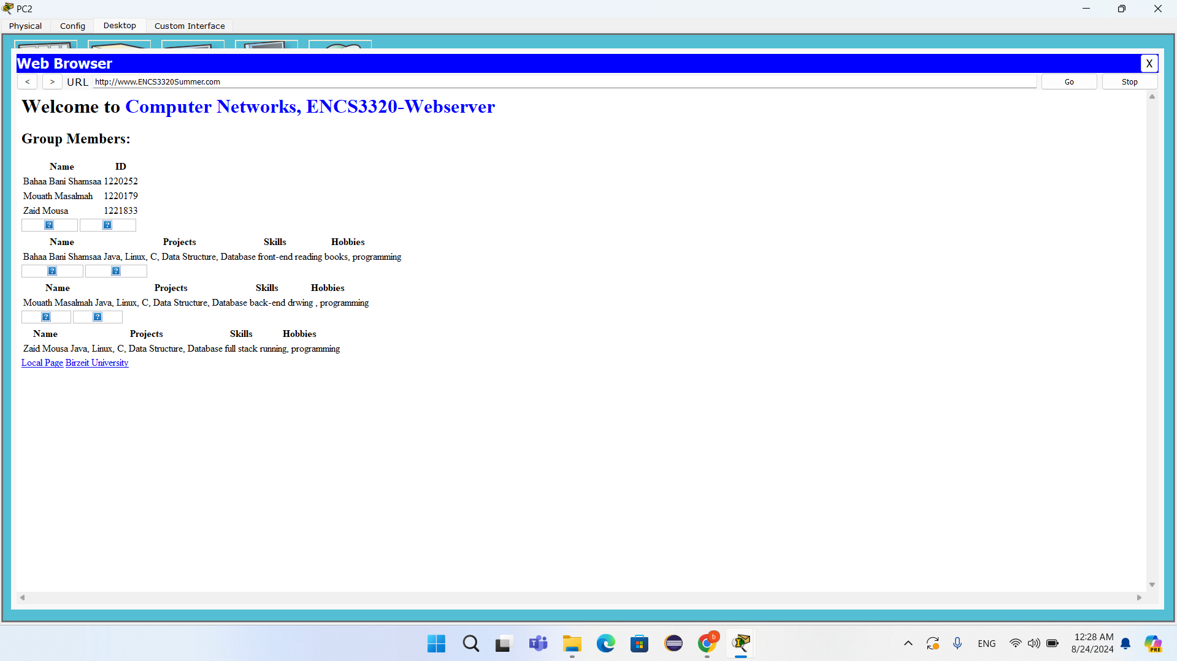

Figure : PC2 Web Page

web page for PC2

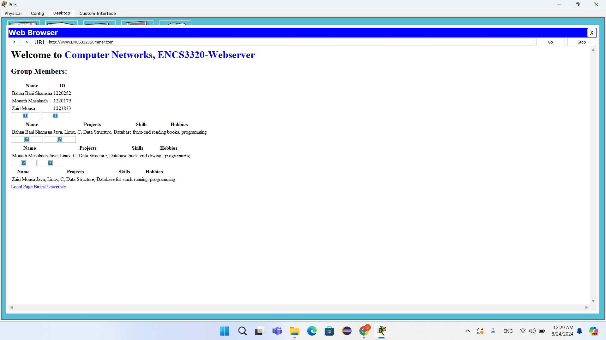

Figure : PC3 Web Page

web page for PC3

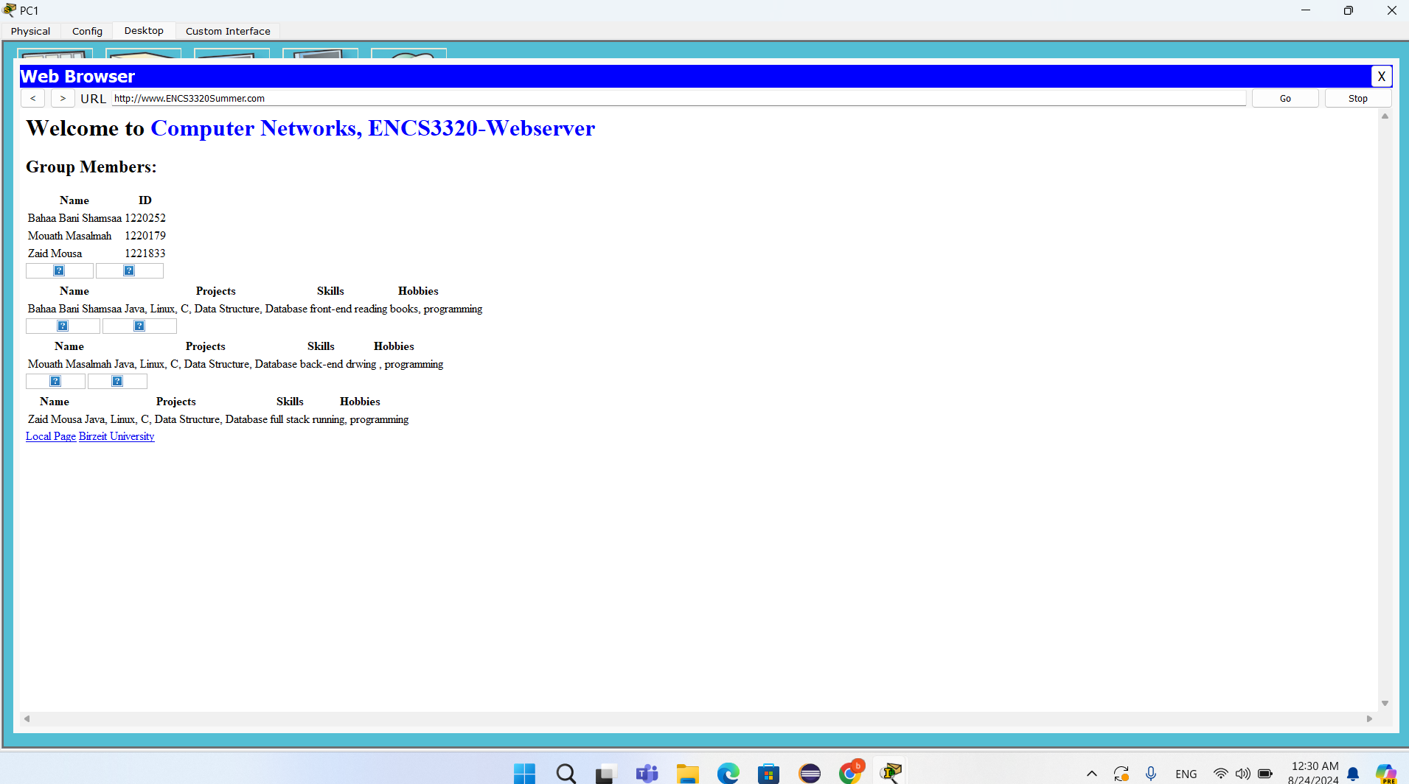

Figure : PC1 Web Page

web page for PC1

# Pie Chart:

Figure : pie chart

# Work and report:

Task 0: Mouath and Zaid

Task 1: Bahaa and Zaid

Task 2: Mouath , Bahaa and Zaid

Task 3: Mouath and Bahaa

Task 4: Mouath , Zaid and Bahaa

# The References:

* [**IPv4**](https://www.geeksforgeeks.org/what-is-ipv4/)
* [**network Gateway**](https://www.cisco.com/c/en/us/products/routers/what-is-a-network-gateway.html)
* [**Packet Tracer**](https://www.geeksforgeeks.org/what-is-cisco-packet-tracer/)
* [**Subnet Mask**](https://www.auvik.com/franklyit/blog/what-is-subnet-mask/)
* [**Tracert**](https://builtin.com/articles/traceroute)